|  |  |
| --- | --- |
| Student: Karwan Kadir  Student P-Number:p11034075 p11034075@myemail.dmu.ac.uk | http://www.curvykate.com/images/2010/logo-dmu.gif |

|  |  |  |
| --- | --- | --- |
| Due By: | Project Performed By: |  |
|  | Student: Karwan Kadir  Student P-Number:p11034075 p11034075@myemail.dmu.ac.uk |  |

IMAT3451 Computing Project

|  |  |
| --- | --- |
|  | **Project Title: Cinema booking system** |

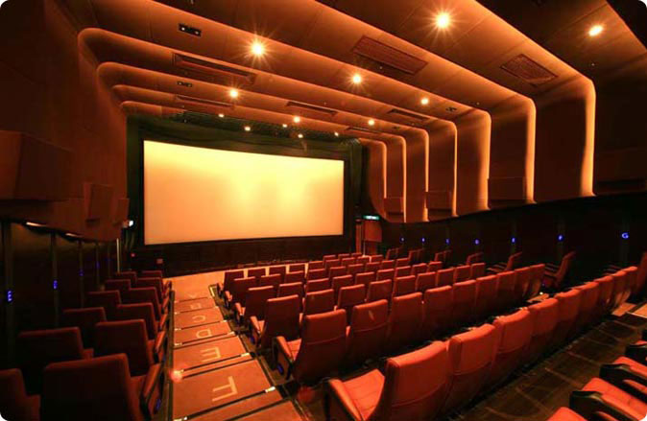

Contents

1- Acknowledgements 4

2- Introduction: 5

3- Purpose: 6

4- OVERVIEW: 7

5- Future scope: 8

6- Design the system: 9

7- Selecting the design solution: 9

8- Project Architecture 10

9- E R Diagram: 15

10- Database schema: 16

11- Store procedure/Trigger name: 17

12- Table structure: 18

Action Filters: 24

Interaction with database: 27

Base Manager Class: 28

13- Use Case Diagrams: 31

14- Register 32

15- Login for cinema user and admin 32

16- GetAdminByUserNameAndPassword 33

Functions and Methods used 33

17- Forgot Password 34

18- Change password for Cinema user and admin 38

19-PayPal 38

Evolution of main components 40

1- Finding a Movie 40

2- Book Ticket 47

3- Add Cinema 56

4- Add Movie 61

5- Registration 67

Critical analysis 73

SHNEIDERMAN’S EIGHT GOLDEN RULES: 75

THE THEORY BEHIND MODEL VIEW CONTROLLER 77

Personal Reflection 79

Appendix 80

Test cases 80

System development approach: 97

Management documentations 98

User Manual: 101

References 118

## 1- Acknowledgements

Many thanks go to the many people who have helped me through this project. My family and friends, especially my partner for the support and encouragement they give me during the course of this work, also special thanks to David Gerard for providing me with advice and direction.

## 2- Introduction:

This project is to create and develop the cinema system, the application is internet base can access anywhere at any time as long as there is internet connection, the system is automatic once the new user register then the user has privilege to access to content of the system, the user can buy single as well as multiple cinema tickets, furthermore the user be able to pick desire seat, the cinema system has seating layout, the layout divided into three parts ( gold, platinum, sky lounge), the user able to print the electronic ticket from users dedicated page (transaction history), once the user reserved the ticket, notification will be sent automatically throughout the system database with the date of the shows as well as seat row and price of the ticket, also , the  system has capability for user to cancel tickets in advance once the ticket canceled they system refund the user automatically .

## 3- Purpose:

The Purpose of this project is to provide and understanding the cinema system, also, the other purpose of the system user can and should be able to buy single of multiple cinema tickets online. Furthermore, to make it easier for those who don’t have spare time to stand in the queue to purchase the cinema tickets, it is an automatic system, as well as the system is to reduce the member of staff in the counter, most of the action completing by the system, member of staff (admin) be able to Add new film, adding new cinema, deleting and editing the movies.

## 4- OVERVIEW:

Providing a ticket booking platform which is ultimately a web application. With the help of this application, the user can book the tickets within few minutes without making much effort. The system is the hassle-free and giving great benefit to the system as well as the end user who comes to a cinema to view a movie. With the help of this system, admin can create multiple cinemas in different cities and configure screens, seats price, and seat categories etc., once the user purchased a ticket the user have would be able to pay for the ticket via PayPal or printing it.

## 5- Future scope:

Although the system I have developed without a doubt there are some issues and certainly is not perfect, to take the system forward will need to make some changes and develop more functionality and introduce more widget to the system, for instant, mobile version, now a days mobile phones almost replacing computer and laptop, they are more capable of surf the internet, having mobile version system will have benefit to user.

Create dedicated pages for contact and support, as well as integrated third party for payment by visa or debit card, the system has a capability for the user to use PayPal to pay for the ticket.

Furthermore, plan to improve the interface for example giving the users power to have personalization option, like so many applications provide user custom workspaces, this makes the user feels more at home, this can be done quite easily and give the user option to customize the look of the system, user be able to select any color or background and many other options, and finally, enable keyboard shortcut for the system which is great feature of modern web application, many web application already use shortcuts, for example, google, eBay, any many more .

## 6- Design the system:

Developing this application, I have used ASP.NET as a front End and SQL Server 2012 Express edition as a backend, I have used visual studio 2013 web express alongside with SQL server management studio 2012.

There are several reasons for choosing ASP.NET, firstly ASP.NET let you to have shorter code, for example, to create an email, can do it with single lined of code can send emails to your clients with less effort. Also, it’s really easy to implement.

WithASP.NET you can be certain with performance, if you have large application and extremely large code, it will perform with no issue. Also, have in-built security features.

## 7- Selecting the design solution:

MVC framework has been used for cinema system project, MVC stand for Model view controller, it’s a software design pattern for developing attractive, well build an application. The MVC breaks down the design into three main areas, it will be separated from each other

Model – This is the backend of the application where all of the data is held. This is the business logic end of the framework, keeping completely separated from the front-end of the application. •

View – This is the frontend of the application where all the data held in the model is interpreted to be shown to the user. This is the user interface of the application.

Controller – The controller is the link between the user and the system. It controls the interactions between the back and front end through messages. For example, if the user requests some data on the view, the controller will pass the message to the model, which will reply with data to the view and be displayed.

The advantage of MVC is the fact that the business and presentation logic are reserved completely out-of-the-way. This allows to make change easily, without affecting the other parts. For example, let’s say the logic of a database needs to modify, the effect will be at the model and will not affect the view or affect the controller.

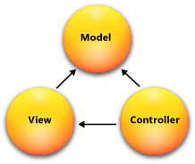

## 8- Project Architecture

The base of the cinema system project Architecture is MVC to make it more robust and safe, I have used layer architecture. Used different project in project solution (as figure show below)

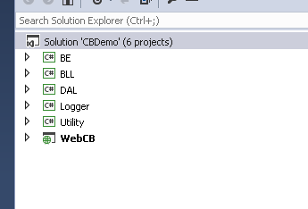

**BE project:** - BE (Business Entities) Project. By the name, it is clear that it is the project where will keep Business entities which will use in the cinema system project. The main advantage of having entities in the separate project it can refer in different project easily. The classes inside the project treated as a model class. It also contains the parameters classes used to pass values into business entity and data access layers for insertion, updating and selection purpose.

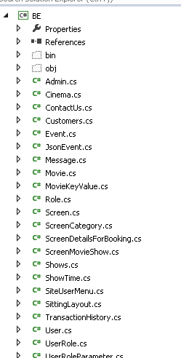

**BLL Project: -**BLL (Business Logical Layer) project. This project is mainly for having Business logic. This is the project which is responsible for calling data layer processing data and interacting with web layer controller. I have followed the standard and calling the files in this project as a manager.

Business Logic Layer contains all module and page specific business logics. It is a middle or central layer which manages interaction between UI and Data Access Layer. It contains multiple manager classes like Admin Manager, Cinema Manager, Customer Manager, Home Manager, Movie Manager, Role Manager and User Manager. All of these manager classes inherits Base on Manager Class, contains multiple base methods like insert, update, delete, and select. These methods are created for the ease of software development. These base methods require stored procedure name and parameters list and on execution it interact with the data access and give the desired output. As base manager is inherited by all manager classes because of this it’s all of the methods are available in all classes inherited it.   Only need to store procedure name and SQL parameter list for this method. Business Logic Layer class methods are called by UI Controller action methods and this request is further forwarded to DAL and then database.

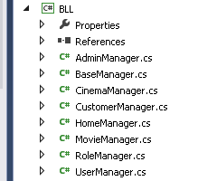

DAL Project: - DAL (Data Access Layer) Project. This project is responsible for the interacting with actual data container like SQL SERVER. The main benefit of using DAL project as the separate project is that it can be changed and point to the different drivers, this project reference can be given to different application like web/windows depends on the situation. It contains the class Database Manager, which contains the insert, update, delete and select methods. These methods are having ado.net object like a command, command parameters, and connection, which further execute operations using command methods and interact with the database. Data Access Layer is used by Business Logic Layer. BLL passes the parameter to DAL’s methods for execution and get the desired result. Along with insert, update, delete, and select Database Manager also have the capability to pass table-valued parameters to stored procedure and can manage multiple output parameters as well.

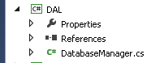

Logger Project: - Logger is the project which is using for logging the error which will raise in the project. To handle the error a 3rd party integrated for error logging system which is Log4net**.**

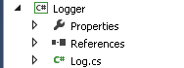

Utility Project: - using Utility project as a common place where keeps configuration, constants, and other common utilities. For example, application configuration class in this project to access the web.config file’s settings. Also having session keys and other constants.

Utility project contains all enum, constants classes, app settings, and extension methods. All these are the utility items commonly used in all projects (Business Logic, Data Access, and Web UI). enum and constant classes are key value classes used to prevent hard bind in all projects, the constant class contains all the stored procedure's name, error messages and other string key values. Enum contains all numeric key value like role type and other. App setting used to fetch all the configuration settings specified in web.config. Extension methods are the methods commonly used c#.

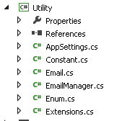

WebCB Project: - WebCB is the main project which has the Web interface and routing logic.  Also have Area in this project. The Area mainly form Admin part and rest other operation will be in the common layout. This project contains CSS, images, layout, JavaScript, cshtml etc.

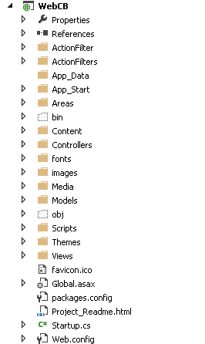

In nutshell below is the image which describe the current solution Architecture layout

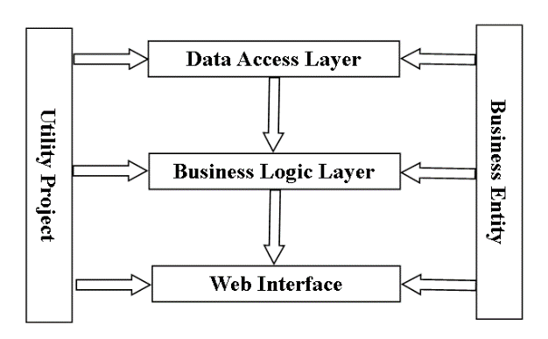

On the backend side currently using SQL SERVER and have used stored procedure for each individual operation for Security and Performance reason. Also created the normalized database with the appropriate selection of datatypes.

## 9- E R Diagram:

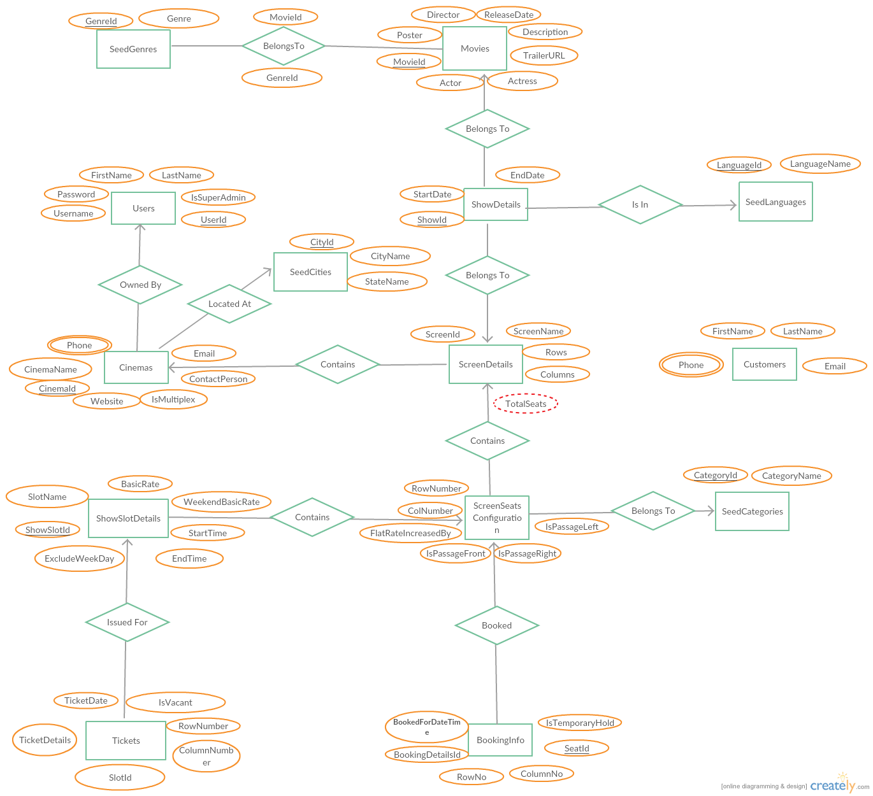

## 10- Database schema:

The database schema looks at what data require to be stored on the model of the application. The data gathered together, creating a basic structure with entities and the connections that take place between them, the data then attached to each of the entities to form the whole structure of the model.

The only changed have been made with the first submission, since then the table seed for language have been removed, as it wasn’t necessary.

## 11- Store procedure/Trigger name:

This section, document the following to establish comprehensive description to guide to develop stored procedures/triggers:

* AddBookingInfo
* AddEvent
* AddScreen
* ChangeCustomerPassword
* CustomerLogin
* DeleteAdminUser
* DeleteCinema
* DeleteEvent
* DeleteMovie
* DeleteScreen
* ForgotPasswordCustomer
* GetAdminByUserNameAndPassword
* GetAdminUserDetailsByUserId
* GetAdminUserList
* GetCinemaList
* GetCinemaListByCinemaNameAndCityId
* GetCinemaListByCityId
* GetCinemaScreen
* GetCityList
* GetCustomerDetailsById
* GetCustomerTransactionHistory
* GetEvent
* GetEvents
* GetGenreList
* GetInstantDetailByCinemaId
* GetMovieDetailsById
* GetMovieList
* GetMovieListByCriteria
* GetMoviesComingSoon
* GetMoviesForHome
* GetMovieShowDetailsById
* GetMoviesKeyValue
* GetMoviesOpeningThisWeek
* GetRoleList
* GetScreenById
* GetScreenCategories
* GetShowDetailsByCinemaId
* GetShowDetailsByCriteria
* GetShowDetailsForBooking
* GetSiteUserMenuItems
* GetUserByUserNameAndPassword
* GetUserList
* GetUserPasswordByUserName
* InsertCinema
* InsertCustomer
* InsertMovie

## 12- Table structure:

|  |  |  |  |  |
| --- | --- | --- | --- | --- |
| **Table Name** | **Users** | | | |
| **Column Name** | **Data Type** | **Primary key** | **Nullabe** | **Change Type** |
| UserId | Int | Y | N | Add |
| UserName | varchar(200) |  |  |  |
| Password | Varchar(20) |  |  |  |
| FName | Varchar(50) |  |  |  |
| LName | Varchar(50) |  |  |  |
| IsSuperAdmin | bit |  |  |  |

|  |  |  |  |  |
| --- | --- | --- | --- | --- |
| **Table Name** | **SeedGenerd** | | | |
| **Column Name** | **Data Type** | **Primary key** | **Nullabe** | **Change Type** |
| GenerId | Tinyint | Y | N |  |
| Gener | varchar(100) |  |  |  |

|  |  |  |  |  |
| --- | --- | --- | --- | --- |
| **Table Name** | **SeedCity** | | | |
| **Column Name** | **Data Type** | **Primary key** | **Nullabe** | **Change Type** |
| CityId | Smallint | Y | N |  |
| CityName | varchar(200) |  | N |  |
| StateName | Varchar(200) |  |  |  |

|  |  |  |  |  |
| --- | --- | --- | --- | --- |
| **Table Name** | **Customer** | | | |
| **Column Name** | **Data Type** | **Primary key** | **Nullabe** | **Change Type** |
| CustomerId | Int | Y | N |  |
| Fname | varchar(100) |  |  |  |
| Lname | Varchar(100) |  |  |  |
| Email | Varchar(200) |  | N |  |
| Phone | Varchar(20) |  | N |  |

|  |  |  |  |  |
| --- | --- | --- | --- | --- |
| **Table Name** | **Cinema** | | | |
| **Column Name** | **Data Type** | **Primary key** | **Nullabe** | **Change Type** |
| CinemaId | Int | Y | N |  |
| CinemaName | varchar(200) |  | N |  |
| Phone | Varchar(20) |  |  |  |
| Email | Varchar(100) |  |  |  |
| Website | Varchar(150) |  |  |  |
| contactPerson | Varchar(200) |  |  |  |
| IsMultiplex | Bit |  | N |  |
| CityID | Smallint |  | N |  |
| CreatedBy | Int |  | N |  |
| ModifiedBy | Int |  |  |  |
| CreatedDate | Datetime |  | N |  |
| ModifiedDate | datetime |  |  |  |

|  |  |  |  |  |
| --- | --- | --- | --- | --- |
| **Table Name** | **Movies** | | | |
| **Column Name** | **Data Type** | **Primary key** | **Nullabe** | **Change Type** |
| MovieId | Int | Y | N |  |
| MovieName | Varchar(200) |  | N |  |
| Hero | Varchar(100) |  |  |  |
| Cast | Varchar(200) |  |  |  |
| Heroine | Varchar(100) |  |  |  |
| Director | Varchar(100) |  |  |  |
| ReleaseDate | Datetime |  |  |  |
| Description | Varchar(200) |  |  |  |
| TrailerULR | Varchar(300) |  |  |  |
| LargerPoster | Image |  |  |  |
| SmallerPoster | Image |  |  |  |

|  |  |  |  |  |
| --- | --- | --- | --- | --- |
| **Table Name** | **MovieGener** | | | |
| **Column Name** | **Data Type** | **Primary key** | **Nullabe** | **Change Type** |
| Id | Int | Y | N |  |
| GenerId | Tinyint |  | N |  |
| MovieId | Int |  | N |  |

|  |  |  |  |  |
| --- | --- | --- | --- | --- |
| **Table Name** | **ScreenDetails** | | | |
| **Column Name** | **Data Type** | **Primary key** | **Nullabe** | **Change Type** |
| ScreenId | Int | Y | N |  |
| ScreenName | varchar(100) |  | N |  |
| CinemaId | Int |  | N |  |
| Columns | Tinyint |  | N |  |
| Rows | Tinyint |  | N |  |
| TotalSeat | Int |  | N |  |

|  |  |  |  |  |
| --- | --- | --- | --- | --- |
| **Table Name** | **ScreenSeatConfiguration** | | | |
| **Column Name** | **Data Type** | **Primary key** | **Nullabe** | **Change Type** |
| Id | Int | Y | N |  |
| ScreenId | Int |  | N |  |
| TicketCategoryId | Tinyint |  | N |  |
| RowNumber | Varchar(2) |  | N |  |
| ColNumber | tinyint |  | N |  |
| IsSeat | Bit |  | N |  |
| IsPassageleft | Bit |  | N |  |
| ISPassageRight | Bit |  | N |  |
| IsPassageFront | Bit |  | N |  |
| ModifiedBy | Int |  |  |  |
| Modifieddate | Datetime |  |  |  |

|  |  |  |  |  |
| --- | --- | --- | --- | --- |
| **Table Name** | **BookingDetails** | | | |
| **Column Name** | **Data Type** | **Primary key** | **Nullabe** | **Change Type** |
| BookingId | Int | Y | N |  |
| BookingDate | Datetime |  | N |  |
| ShowId | Int |  | N |  |
| BookedBy | Int |  | N |  |
| ShowDate | Datetime |  | N |  |
| NoOfTickets | Tinyint |  | N |  |
| ShowSlotId | Int |  | N |  |
| TotalAmount | Numeric(18,0) |  | N |  |
| Discount | Numeric(18,0) |  |  |  |

|  |  |  |  |  |
| --- | --- | --- | --- | --- |
| **Table Name** | **ShowDetails** | | | |
| **Column Name** | **Data Type** | **Primary key** | **Nullabe** | **Change Type** |
| ShowId | Int | Y | N |  |
| ScreenId | Int |  | N |  |
| MovieId | Int |  | N |  |
| StartDate | Date |  | N |  |
| EndDate | Date |  | N |  |

|  |  |  |  |  |
| --- | --- | --- | --- | --- |
| **Table Name** | **ShowSlotDetails** | | | |
| **Column Name** | **Data Type** | **Primary key** | **Nullabe** | **Change Type** |
| ShowSlotId | Int | Y | N |  |
| SlotName | Varchar(100) |  | N |  |
| ScreenId | Int |  | N |  |
| StartTime | Time(7) |  | N |  |
| EndTime | Time(7) |  | N |  |
| ExcludeWeekDay | Bit |  | N |  |
| BasicRate | Smallint |  | N |  |
| WeekEndBasicRate | Smallint |  | N |  |

|  |  |  |  |  |
| --- | --- | --- | --- | --- |
| **Table Name** | **Tickets** | | | |
| **Column Name** | **Data Type** | **Primary key** | **Nullabe** | **Change Type** |
| TicketDetailId | Int | Y | N |  |
| TicketDate | Datetime |  | N |  |
| SlotId | Int |  | N |  |
| RowNo | Tinyint |  | N |  |
| ColumnNo | Tinyint |  | N |  |
| IsVaccant | Bit |  | N |  |

## Action Filters:

In WEBCB project, Action Filters has been implemented. Action filters ensure security by authentication and authorization filters which mean all the actions or better way to say can view (specified) can only be accessible if they passed from Action Filters. The major reason for introducing Action filter is preventing unnecessary check.

**Two different Action Filters has been implemented for this project**

**1- Authenticate User** **Action Filter**: This filter making sure that those actions which require authentication and Authorization for the user should go through this filter, if the user is  not logged in then this filter will force the user to Log in into the system to proceed further operation.

**2- Authenticate Admin User Filter:** This filter making sure that those actions which required Admin Authentication and Authorization for Admin Area should filter which means if an Admin is not logged in and does not belong to a particular role then it will not be able to access that particular Controller or Action. Below is an image of coding for the filter.

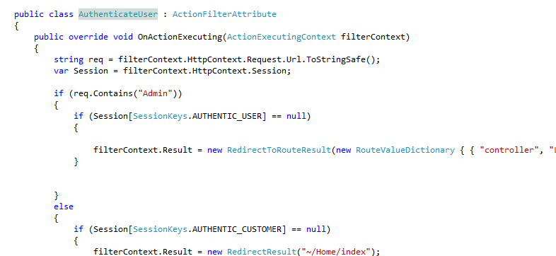

**Data Annotations Models:** With each master entities which is doing some master operation like add/edit/delete can apply differents kind of validation like required field, Name of the field , Minimum length , max length , data type etc. on fields. Whenever creating an entities will take reference of “System Component Model Data Annotations” and set different attributes of the fields. These entities can be found in BE project.

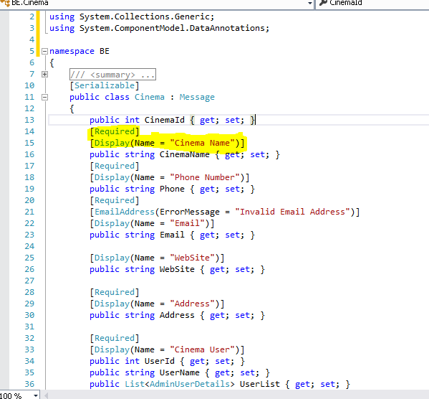

Areas: - Area is one of the best features which is used in the project. The Area is segregation or defining different boundaries according to project need. For the cinema system project, defined Area for Admin users and common users. The Area has its own folder structure for the Controller, View, and Model.  Coding related to admin is in Admin Area while for the common user are using default structure (nonArea), Below is an area structure.

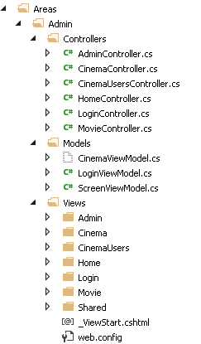

Controller:  Controller created according to their functionality or scope of the work. For example, A Home Controller contains functions related to Home page for an instant, change Showing Movie listing, Handling POP of registration, handling logout etc.

Similarly, same analogy followed and added different Controllers. As can be seen from Cinema Controller for Cinema related work, CinemaUserController for Cinema user’s related tasks, LoginController for Login, MovieController etc.

There are certain rules for controller.

1-Controller which requires Authentication & should have AuthroizationFilter

attribute as shown in below figure.

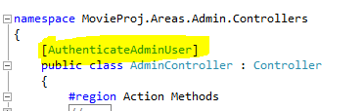

If unable to apply on the controller due to some reasons the authentication attributes on method can be applied if required

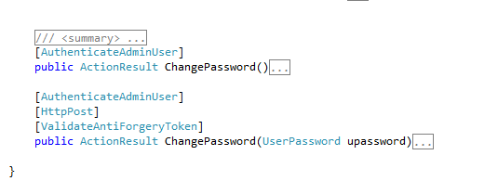

2- HttpGet used to for security reasons. Use HttpPost explicitly where required.

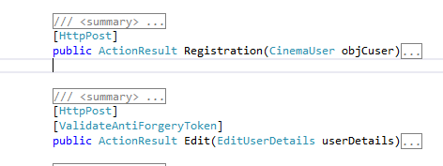

## Interaction with database:

The database manager class of DAL project is responsible for connectivity of database. This class contains the generic method of Insert, update, delete, and select. Generic methods have been implemented so it can handle one or multiple parameters. Needs to pass stored procedure name and SQL parameters list if required. this class has been written in such a manner that does not requires to writes Database operation at multiple places, stored procedures used to interact with the database

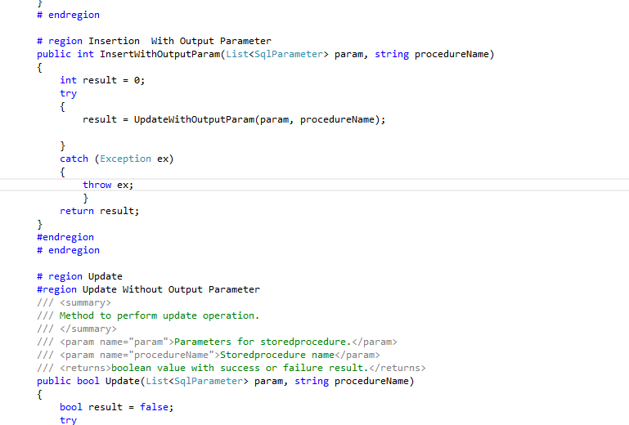

## Base Manager Class:

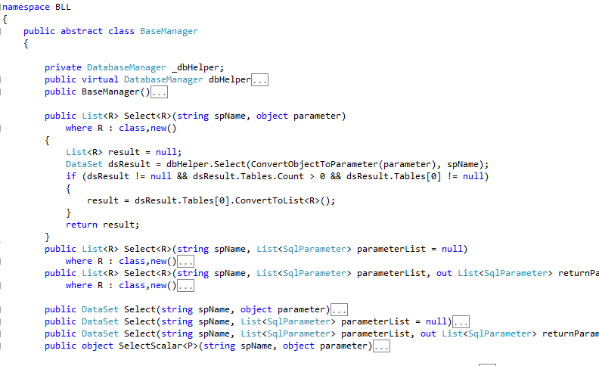 Base Manager Class in BLL project is one of the main classes. The base class is inherited by other classes which exist in BLL project. It is an Abstract class it does mean no one be able to create an instance of this class it is treated as must inherit class. This class is designed in a generic way that all database interaction can easily handle with this class.

Whenever any Manager class inherits it. That class can utilize the functions of BaseManager.

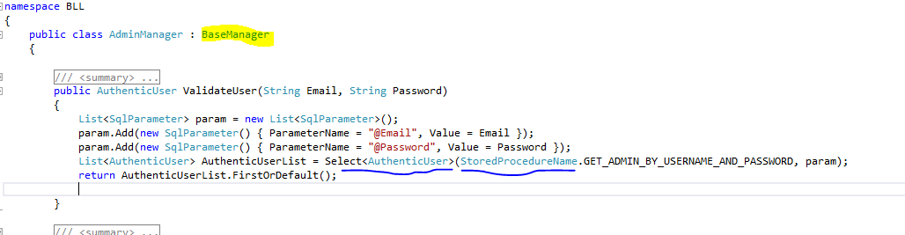

As can be seen the figure above. AdminManager which inherited BaseManager. BaseManager’s Generic function “Select” is used which return List of AuthenticUser and for the Base manager, different ways of Selecting method and all return variety, for example, Generic class, List of Generic Class, Dataset, object etc. according to code need .

Broadly sketch the lines of the project architecture ,below are the points

1-View (HTML) comes in view folder but it totally depends upon the Area of interest if the functionality related with Admin /CinemaUser then it will fall under Admin Area else will be in root. All images should be in the images folder and all External Java script files should be in Scripts folder.

2-Model classes will be defined in BE project. Called in Business Entities in the cinema system project. And can apply different annotations like Required, Max length, Min length, format, and data types depends upon program need.

3-According to functionality Define controller and methods. If Controller and methods required authentication attributes then can apply authentication attributes

4-In BLL project create Manager Class according to functionality or role. The Business Manager class should be inherited by Base Manager Class which we defined.

5-Create stored procedures in database to perform certain tasks don’t use inline functions.

6-Define constants of stored procedure name in Utility project’s constant class.

7-Define error and success message also in Utility project’s message constants classes.

Different sequence and diagram has been implemented which make it easier to understand.

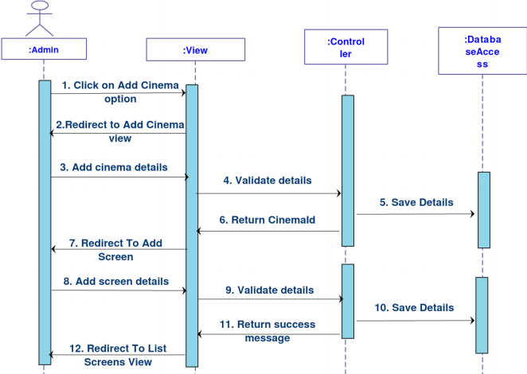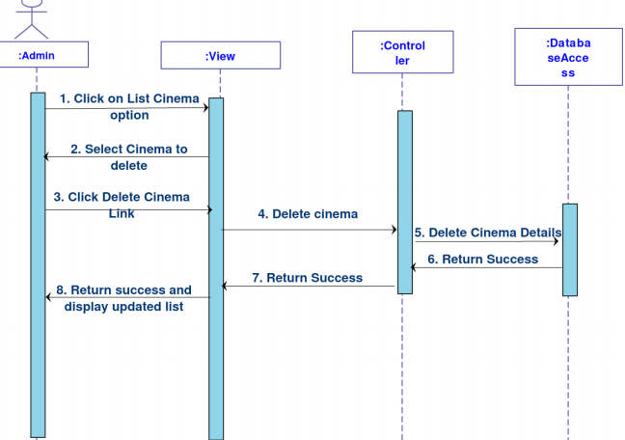

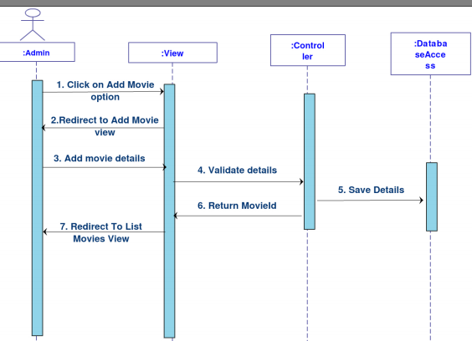

## 13- Use Case Diagrams:

The Use Case Diagrams indication the usage requirements of a cinema system, especially finding and splitting the new applications functionality. The diagrams will establish actors and use cases. The diagram for customer and admin for this application can be found below

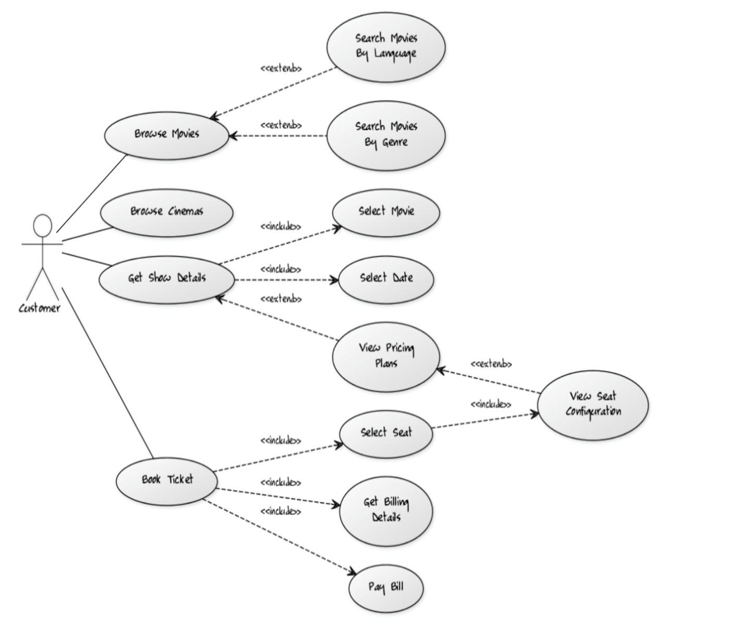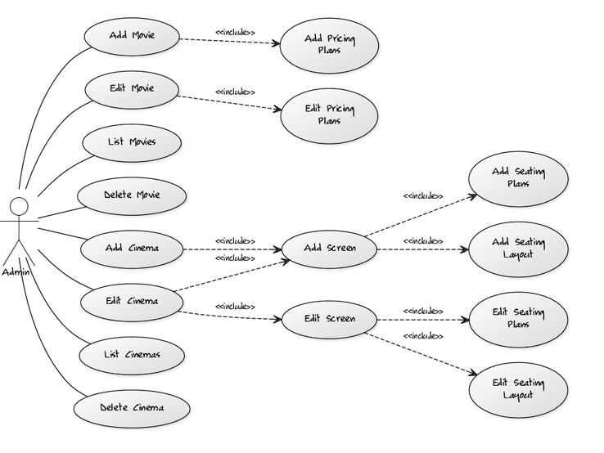

## 14- Register

Accessing the system user need to be registered, if the user does not hold an account on the application, they are able to register and access the application as a valid user, this requires the user to fill in their details, which includes name, last name, phone number, Email address. Once the user entered all mandatory fields, the system database will send a confirmation to the email provided by the user to verify the user.

## 15- Login for cinema user and admin

Login to the system will help the authentic user to access the application, the authentic user needs to provide a valid username and password.

**There are several ways design login and access to the system.**

### 15.1- Login by Facebook or LinkedIn

The User required to enter an email address to the Facebook account which has to be the same email address provided to the cinema booking system, if the email address does not match the original one provided by the user, the access will be denied. This option is not viable to cinema system as need 3rd party integration.

### 15.2- Tow Factor Login

This option user needs to provide valid username & Password end user needs to provide code which will be sent by Application over E-mail or Phone. Again for cinema system, it’s not viable at this moment of time but can be added in the future if needed be, furthermore, with this option. It requires 3rd party SMS and email service

### 15.3- What is two-factor Login

Two-factor Authentication It’s an extra layer for security reason, with this method the user need to know the username and password as well as an extra information which the user only knows, by having the password, login details and the piece of information it will make harder for someone to gain access and take personal details.

### 15.4- Login by providing username and password

Registered user needs to provide username and password which the user registered with the system, I have chosen this method as I believe it’s more common and more efficient as well as secure.

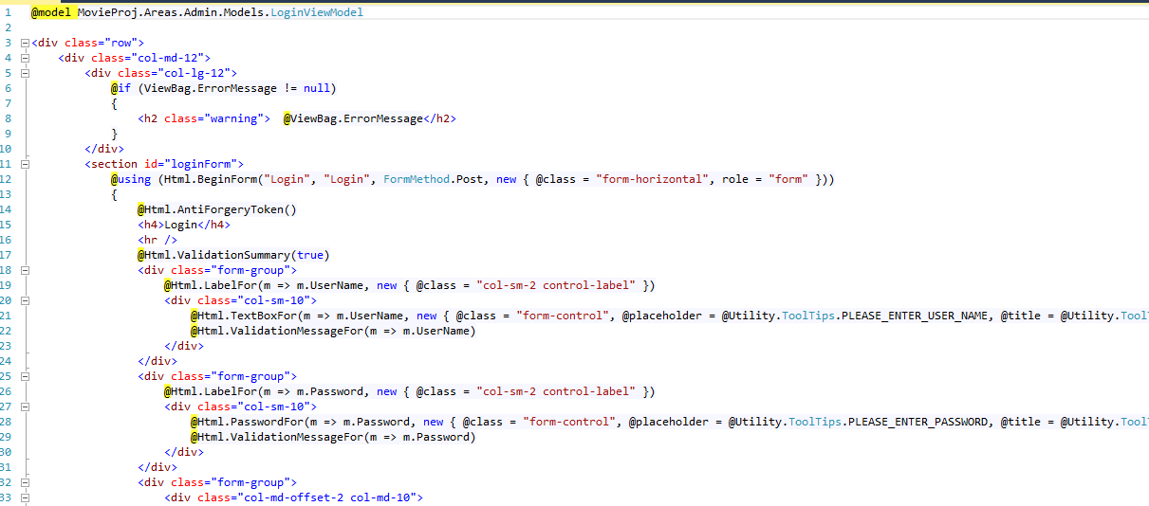Below is screen shot code for user login?

## 16- GetAdminByUserNameAndPassword

## Functions and Methods used

In Login functionality index and Login functions has been implemented, which defined in Login controller. In the login area, I have used HttpPost attribute and to protect from CSRF and using ValidateAntiForgeryToken.

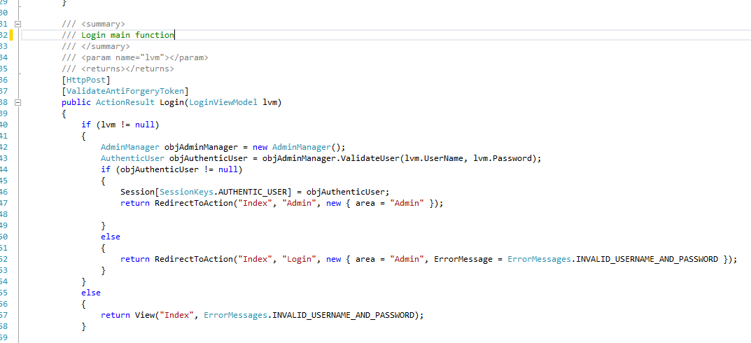For data access, Manager Class has been implemented which is define in another project “BLL”. For this method if the user is valid authentic user then will be saving session of the user. Also using default session timeout.

## 17- Forgot Password

#### The main objective of this user case is to provide facility to the end user to

#### recover forgot the password. In this instant, registered user has to provide a valid

#### username (E-mail) to get the users password on registered E-mail.

#### There are various options of design exists for forgot password functionality.

### 17.1- Show the Password on Screen

#### This option is not very popular with many developers as it is not a good solution

#### because the system does not know whether the user is authentic or not. Another

#### downside of this method is the user might be visually blind which makes it difficult

#### for the user see the password.

### 17.2- Two-Factor Authentication

This is another option the user can be asked to provide two-way authentication like either ask OTP (one-time password pin) which is shared on his/her mobile to identify a genuine user.

### 17.3- Receiving automated phone call.

Another option to recover the password, once all the relevant details are entered then the system will phone the user automatically and system reveals the password to the user, Microsoft recently implemented this method, the potential drawback is the users having the hearing issue.

### 17.4- recover password with secret question

This method requires to answers secret question which provided by the user when they signed up to the system, to recover the password user has to answer all the secret questions right, which of course can always be forgotten.

For cinema booking system I have chosen Send Password option from the options above because it is the simplest way to send password and arguably less time consuming to the users, and there is no extra cost of SMS. Assuming, email is registered with the system is valid.

### 17.5- Design

To design this functionality, I have used a module view controller (MVC) view which is a CSHTML type. I took this type of file because it is light weight and easy to load. In this file, I am using HTML syntax driven by MVC. To make the design responsive and I am using Bootstrap CSS. In the below snap of view, you will find @html. (AntiForgeryToken) to protect the site from CSRF (Cross Site Request Forgery).

### 17.6- Bootsstraps.css

Cascading Style Sheet (CSS), it's a feature added to HTML, cascading style sheet gives the developer more control over how website and pages appear and display, for example developer can add new style sheet to the page or add new font, color, as well as to make the text bold or italic or any other styles, so CSS made the pages much more appealing and also made the life of developer much easier.

### 17.7- AntiForgeryToken

Cross-site request forgery (XSRF or CSRF) is a method of attacking a [Web site](http://searchsoa.techtarget.com/definition/Web-site) in which an intruder masquerades as a legitimate and trusted user. An XSRF attack can be used to modify [firewall](http://searchsecurity.techtarget.com/definition/firewall) settings, post unauthorized data on a forum or conduct fraudulent financial transactions. A compromised user may never know that such an attack has occurred. If the user does find out about an attack, it may only be after the damage has been done and a remedy may be impossible.

The impact of a successful cross-site request forgery attack is limited to the capabilities exposed by the vulnerable application. For example, this attack could result in a transfer of funds, changing a password, or purchasing an item in the user's context. In effect, CSRF attacks are used by an attacker to make a target system perform a function (funds Transfer, form submission etc.) via the target's browser without knowledge of the target user, at least until the unauthorized function has been committed.

To help prevent CSRF attacks, ASP.NET MVC uses anti-forgery tokens, also called request verification tokens.

* The client requests an HTML page that contains a form.
* The server includes two tokens in the response. One token is sent as a cookie. The other is placed in a hidden form field. The tokens are generated randomly so that an adversary cannot guess the values.
* When the client submits the form, it must send both tokens back to the server. The client sends the cookie token as a cookie, and it sends the form token inside the form data. (A browser client automatically does this when the user submits the form.)
* If a request does not include both tokens, the server disallows the request.

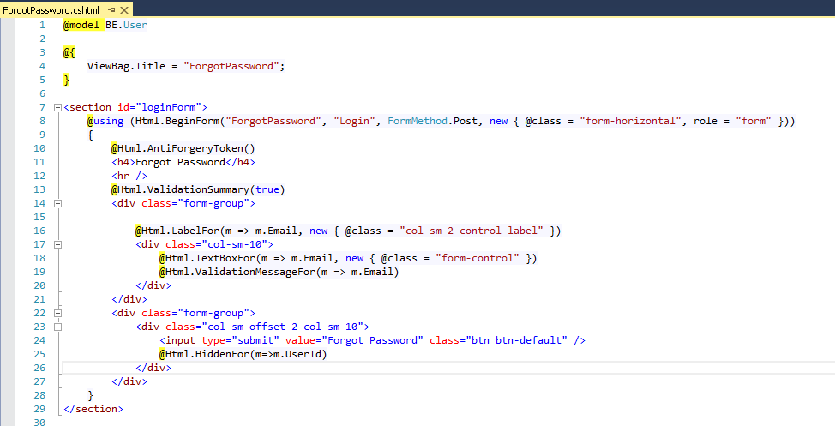Anti-forgery tokens work because the malicious page cannot read the user’s tokens, due to same-origin policies. ([Same-origin policies](http://www.w3.org/Security/wiki/Same_Origin_Policy) prevent documents hosted on two different sites from accessing each other’s content.)

## 18- Change password for Cinema user and admin

Changing password for cinema system, first step, the user has to have used the system before and complete the registration, used need to provide email address to access the system from there the user able to change the password for any particular reason there are some reasons people want to change the password, for instant if the user believes someone else using their account.

### 18.1- Design

HTML5 & cascading style sheet level3 (CSS3) with bootstrap was used for this project. I have set a certain constraint were set for length & strength password which ensure that the users password more secure, nowadays almost every application using this method to make sure users personal data are safe.

### 18.2- What is bootstrap?

A bootstrap is a cascading Style Sheet (CSS) and JavaScript frame work that can be used for creating an application or websites.

## 19-PayPal

For the project I have used PayPal just to test if the user able to pay the payment through PayPal , at this moment of time the PayPal payment system is disabled, just for precautionary measure. Business key is the important key in which admin or cinema owner needs to provide the PayPal account and email in which would like payment go into the account. If IsSandBox value is true then it means you are working in testing environment, to make it actual or live , the value has to be changed from true to false .

A part from this the user have to change the URL or return , cancel_return, notify_url value if the original deployed site URL.

If skippaypal value is true it does means the user only will get PayPal screen and tickets information.

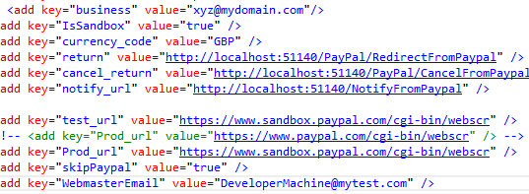

## Evolution of main components

## ­­1- Finding a Movie

**Description:**

Viewing a movie list or searching for a movie can be considered as the heart of a movie ticket booking website. This use case deals with searching of a movie and viewing its details. This use case allows the user to search not only the current showing but also the upcoming movies as well.

**Actors: User**

**Basic Flow of Events:**

1-User logs on to the website.

2-From the drop-down menu, the user selects List Movies option.

3-the User may search the movie by typing complete/partial name of the movie in the search box followed by clicking on Search button.

4-Brief details of the movie would appear on the screen. To view more details, the user may click on the Movie from which would redirect him to the Movie details page.

**Pre-Condition**:  The movie must have been added to the system by an admin user.

**Post-Condition**: A detailed view of the movie, along with the trailers, posters and show timings, would be displayed on the screen.

**Evolution**: In the beginning of the development phase, the list movies page showed movies in a grid view, like other list pages show to admin. To make it look more attractive to the end user, it was then I have re-designed to display brief details along with images to make it visually appealing and pleasing to the system user. A search option was also added in case a user wants to search a specific movie and avoid unnecessary scrolling, thereby improving a user experience.

**Coding**: The architecture followed for this use case is the same as other use cases. The difference being that the module has been repeated for the admin user and the end user with minor functionality changes. Whereas the customer gets an option to book movie ticket in the movie details box on the list movies page, the admin user gets an option to edit the movie. As for the view, there is a template which is used to display individual movie details, which is repeated for all available movies. A point to note here is that not all movies are listed simultaneously. The user may have to iterate through multiple pages to view all the movies.

To search movie, there is a separate view for listing.

**View Detail**

Movies are a long list, would wanted to show limited movies on the page and provide a user paging facility. The image below shows how IpagedList is used mainly to provide the paging facility. IPagedList can be downloaded from Nugetpackage if required.

As for the view, there is a template, used to display individual movie details, which is repeated for all available movies. An important point to note here is that not all movies are listed in one go. The User may have to iterate through multiple 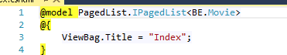pages to view all the movies.

In the view, a search textbox is provided and surrounded by form tag of HTML (HTML.BeginForm). When a user enters the text value and clicks on search button the user has to enter a value in the searching logic.

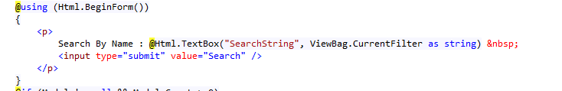

To prevent an error model count and model is null condition .Once this condition is passed. The code is been implemented for loop for the model list where the model is a movie. for each movie is the defined structure, the value of each attributes with @item.property name, below is an image of the coding structure.

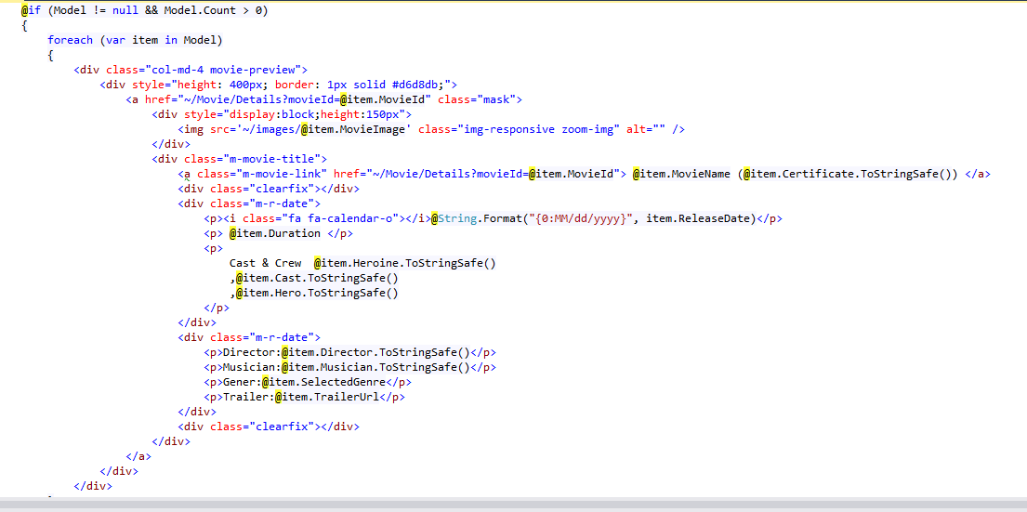

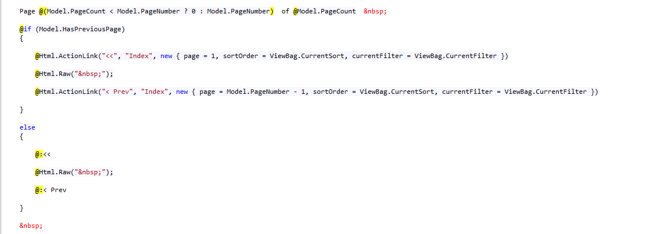

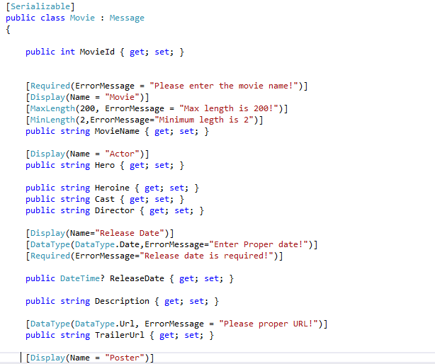The movie class has been created in BE Project which is Business Entities project. The figure can be seen below there is a Movie class which **Serializable** and inherited by **Message** class where message class is responsible for showing success and failure notification on view. The same class are using for Add and Edit functionality, it is a generic class for this operation. This class has all the attributes of the movie like movie name, Hero, Heroine etc.

The controller has been created which enables specific movie details, such as cast and director to be found using SQL. In addition, for searching movies there is an index page which is a default page to making it easier for the user to navigate around the system.

1-CurrentFilter

2-SearchString

3-Page – Page number

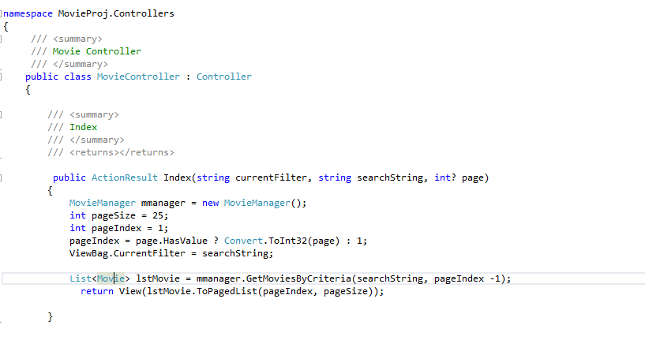

The Index method being used is default pagesize 25, restricting the number of movies on one page to a maximum of 25.

The Default page index is 1 which is changeable by Page parameter.

Creating object of MovieManager class which has method GetMovieByCriteria and passing parameters for this function.  We get the result as a List of the movie which we pass in view.

movie manager class in Business Logic Layer project (BLL) has been created which is inherited by BaseManager and it is a mandatory condition.

For searching specific the following “GetMoviesByCriteria” method used which MovieName & offset parameter. The parameters are treated as SQL parameters and added this parameter as List of SQL Parameters.

base manager function select which return Movie list and in this function passes stored procedure name which is defined in Constant class in Utility project and parameters which have been created. Figure can be seen below

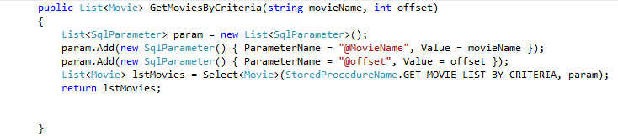

The figure below is a stored procedure, function and XML function has been used to concatenate on the movie categories and used to fetch offset feature for paging.

da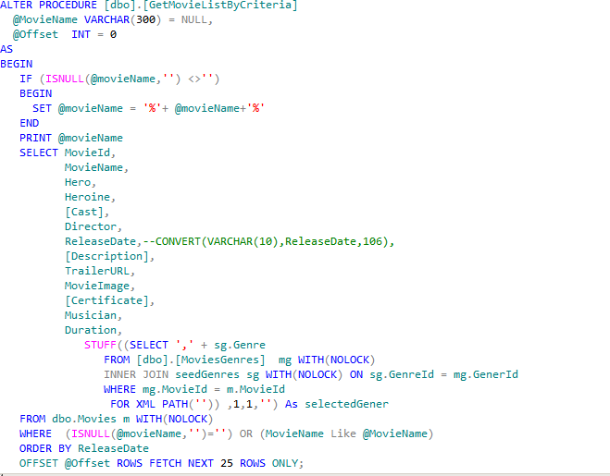

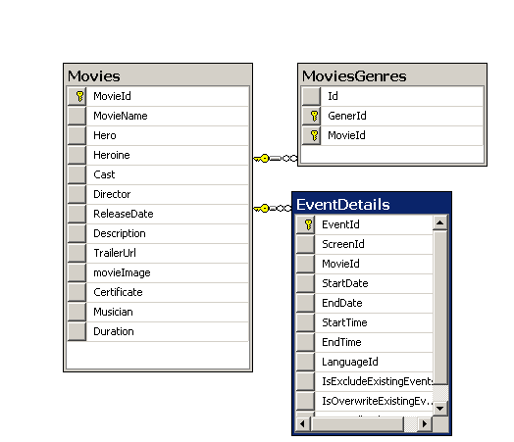Database interaction for finding movie

**Things I have Done Right**: One of the advantages of having this architecture was limiting the number of movies displayed. With time, the number of movies could grow out of control, getting them all from the database in one go could result in high network traffic, which could have slowed down the system. To improve performance and provide quick response to the user, only limited number of records, same as that displayed on one page on UI, is fetched from the database, decreasing the network load.

**Problems Faced**: The major problem was how to design an interactive, user-friendly and good-looking UI. Another issue is the varying image sizes of the posters and the URLs of trailers. To provide a complete look and feel of YouTube, it was essential that to embed the video, which requires a special embed URL provided by YouTube and not just the URL displayed on the video link.

**Improvements / Enhancements**: If a similar requirement comes up in future, would try to enhance the user experience. For example, add comments section on movie details page where the users can provide their feedback on the movie. Also, creating customer ratings and make it visible to the users (both the critic rating as well as the customer rating) on the List Movies page as soon as the user hovers over the movie. Although the system SEO compatible.

## 2- Book Ticket

#### Description: User can book a ticket after selecting the desired show of the desired movie and cinema.

#### Actors: customer

#### **Basic Flow of Events:**

#### 1-User selects the desired show from the available show list.

2-The system prompts the user to enter the number of tickets required and other required details.

3-User selects seat from the displayed screen layout.

4-An invoice, containing details about the billing amount is generated.

5-User is then redirected to a payment portal.

6-Ticket booked is mailed to the user.

**Pre-Condition**: User must select movie and date to get the list of shows available.

**Post Condition**: Details of the booked ticket are updated in the system, along with notifying the user.

**Evolution**: In the beginning, the Booking page showed a normal dropdown of movie and textbox for a number of tickets. To make it look more attractive to the end user, it was then re-designed to display brief details along with images to make it visually appealing and pleasing which give a real structure of actual cinema auditorium.

Different color scheme for seat booking is added to show whether the seat is vacant or occupied.

The layout of seats designs in such a manner by which end user can have exact relation with actual seat arrangement in the auditorium.

Coding: The architecture followed for this use case is the same as done for other use cases. The difference being that the module. I have checked the seat status after post click as well via AJAX feature. As for the view, the cinema auditorium layout is created and used JavaScript extensively to manage run-time booking amount calculation and booking seat color change.

A Model binding used For bookingMovieTicket view as the figure showing below.

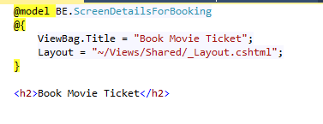

“ScreenDetailsForBooking” is defined in BE project. And it has all the relevant property which is required to design the screen. This class is serialized class as shown in below image.

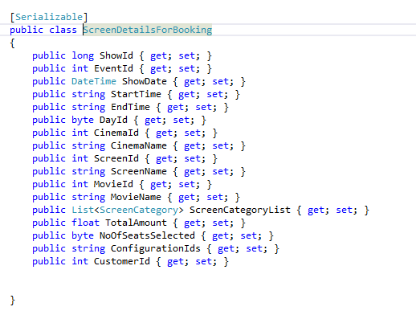

The view of this class helps to render the layout.

As can be seen image below this all code written to show header of the page where show header, for example showing the movie detail, show timing now of tickets drop-down option, cinema name, screen name , date, Time, and  Total amount.

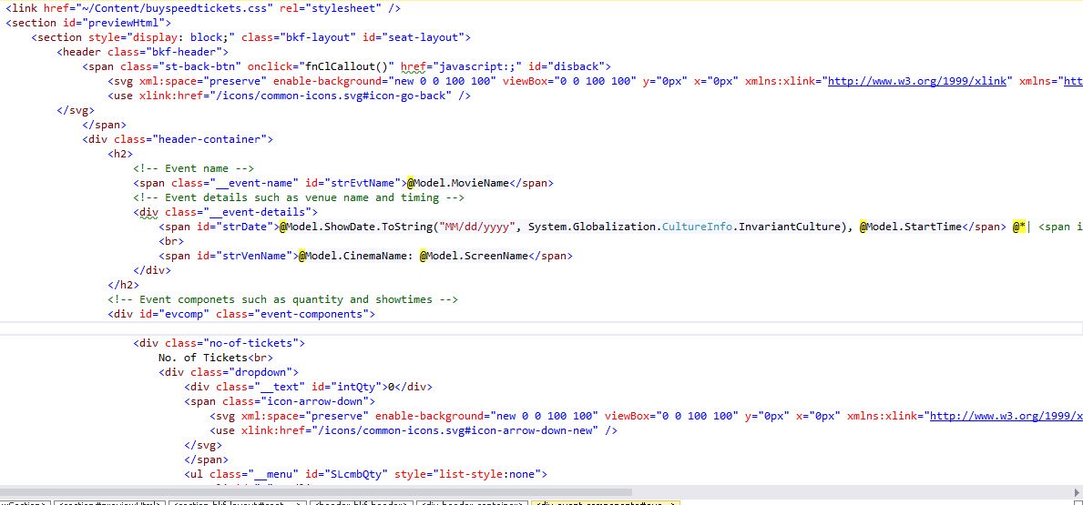

The main functionality which is responsible for seat layout. In this container, determine all the seating category of the particular cinema’s screen (passing through the model,). Once added all necessary, next is to run for loop for each category and determine minRownumber, MaxRownumber, as figure shown below.

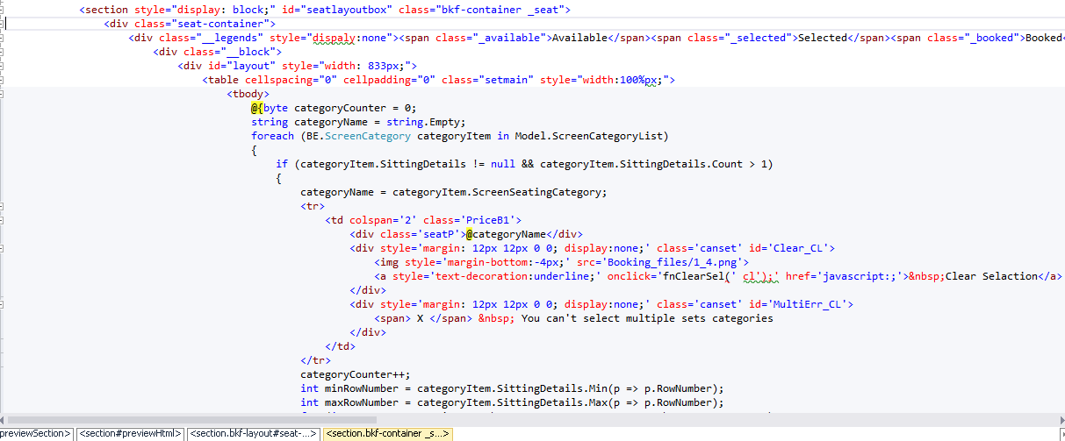

Once added the minRow Number and Max Row number. again run a loop for seating layout.

In the layout, div has been used to bind with seat and if the seat is vacant then apply a different CSS and if the seat is not vacant then apply a different CSS class. As the figure shows below.

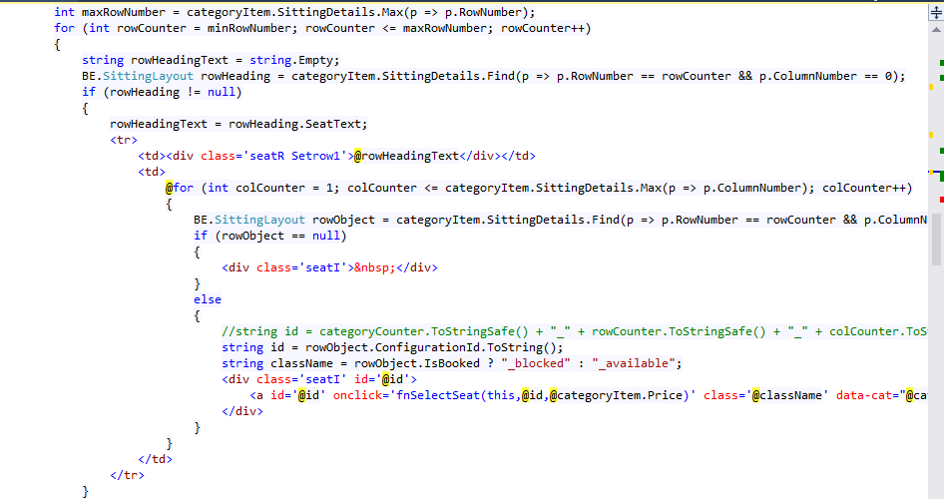

Also, calculate the seating price when user adding or remove any seat from their selection, see the figure below

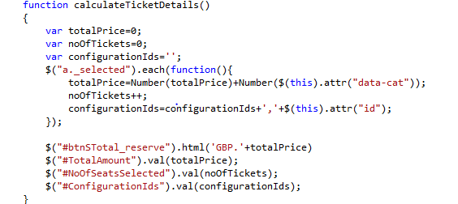

At this stage if everything is correct and the user wants to book the ticket. Then the user will click on the button of book ticket the system will produce the ticket once all the validation passed then the function pass the value of booking to controller method and save the value.

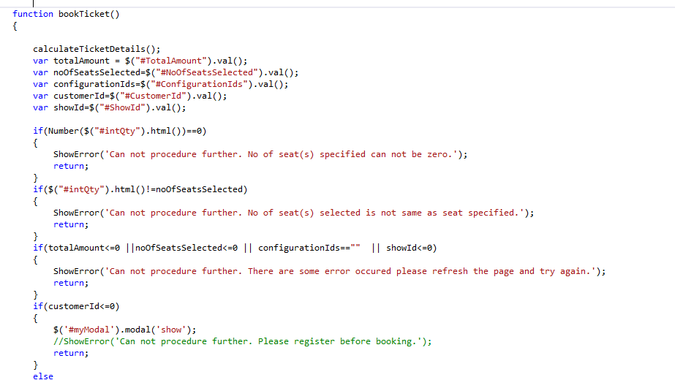

On the controller side, below code has been written in BookMovieTicket method. a Method has been created for AddBookingInfo in CinemaManager. Which has showId, noOfSeatsSelected, configurationIds,customerId, totalAmount.

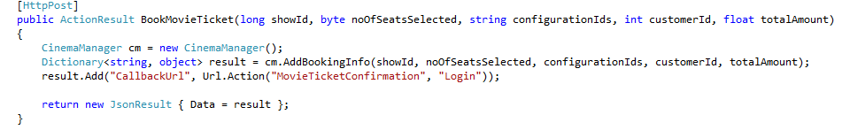

The figure below is the AddBookingInfo method. In which include SQLParameter list and invoke stored procedure “Add_Booking_Info” which is a stored procedure name in utility class.

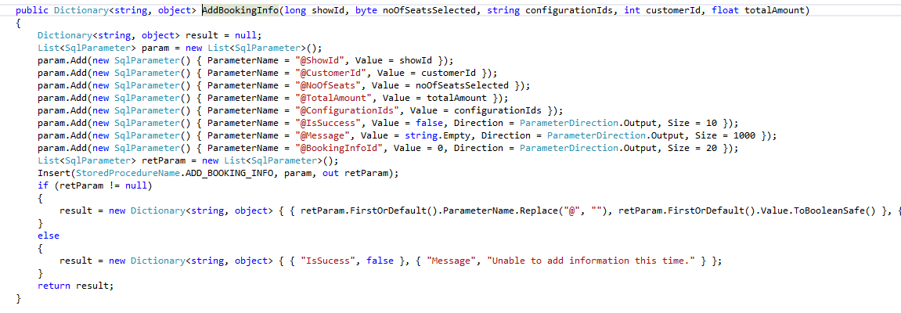

Also wrote following stored procedure. The stored procedure is very complex in nature.  common separated ID in configurationIds is xml.

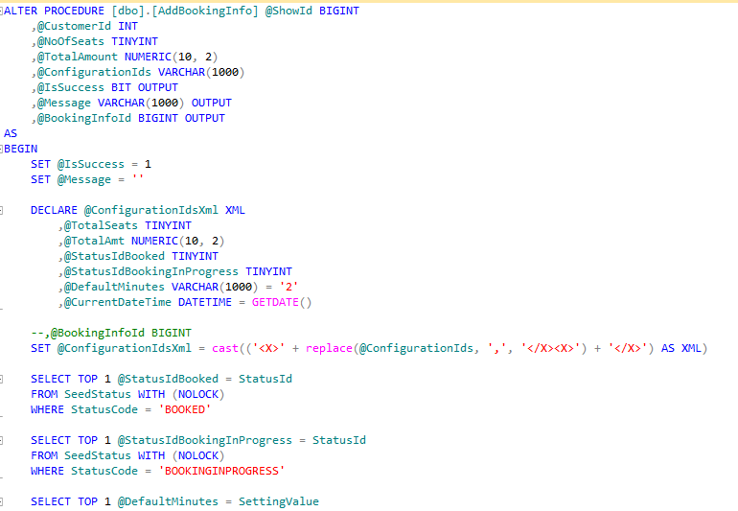

Determined different validation condition once every condition is full fill. booking info and seat info is inserted with following statements.

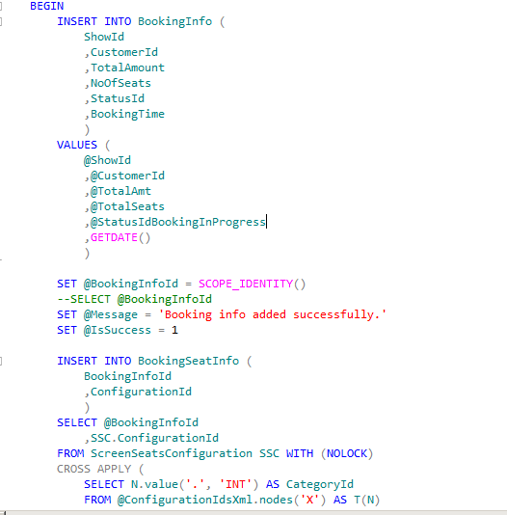

Database interaction for booking details



**Things I have Done Right**: a positive aspect about this architecture was it gives you flexibility. One a key future about the design is that it gives the end user an exact replication of seating layout of cinema auditorium. Even though the program contains multiple examples of JavaScript, its use does not impact on performance. Color coding is used to help the end user to locate vacant and occupied seats and also added a feature to calculate pricing at a run time. To improve performance and provide quick response to the user.

**Problems Faced**: The major problem faced was to design an interactive, user-friendly and good-looking UI. How to make UI /UX such a way that end user can feel it. Needed to show seating arrangement but for each individual cinema auditorium it might be different. So how to show seating arrangement is one of the challenging tasks I couldn’t solve it easily.

**Improvements / Enhancements**: to Improve this user case, when you are booking a specific row tickets and on the same time someone else (another user) started booking and suppose he/she booked, while you are still on booking page then you will not get any notification on the screen or color of recently booked seat is not change on different client’s screen. I was thinking about this particular issue and I might do the design differently and try to make a service which supports from the server and updates the relevant seats status if any user opened it at that particular time.

## 3- Add Cinema

Description: the system allows handling of multiple cinemas at the same time. This use case allows the user to add details of a new cinema in the system.

Actors: Admin

**Basic Flow of Events:**

1-User selects the option to add a new cinema.

2-User enters details like name, location, a number of screens etc.

3-There must be a default screen associated with the cinema and hence, the user needs to add screen details for the cinema.

4-After associating the screen with the cinema, the user defines the seating layout for the corresponding movie screen, along with specifying the basic price plans for the same.

**Pre-Condition**: the User must be logged in as admin.

**Post Condition**: A new cinema and screen details are added to the system and movie shows can now be associated with them.

**Coding**: The architecture followed for this use case is the same for other use cases. The difference being of the module. To add cinema basic details, for example, Cinema name, owner, address etc. required to drill down for another page where would be able to show the listing of existing screen and that page provides the option to add more screen, CSV text format implemented to design the screen.

To add cinema , required to AddCinema view in Cinema folder.

AddCinema view is strongly bind with Cinema class which is defined in BE project. All the property of Cinema class is used with @html tag as figure show below.  Also added Validation Message which shows desire validation message and defined in Cinema class of Business entity.

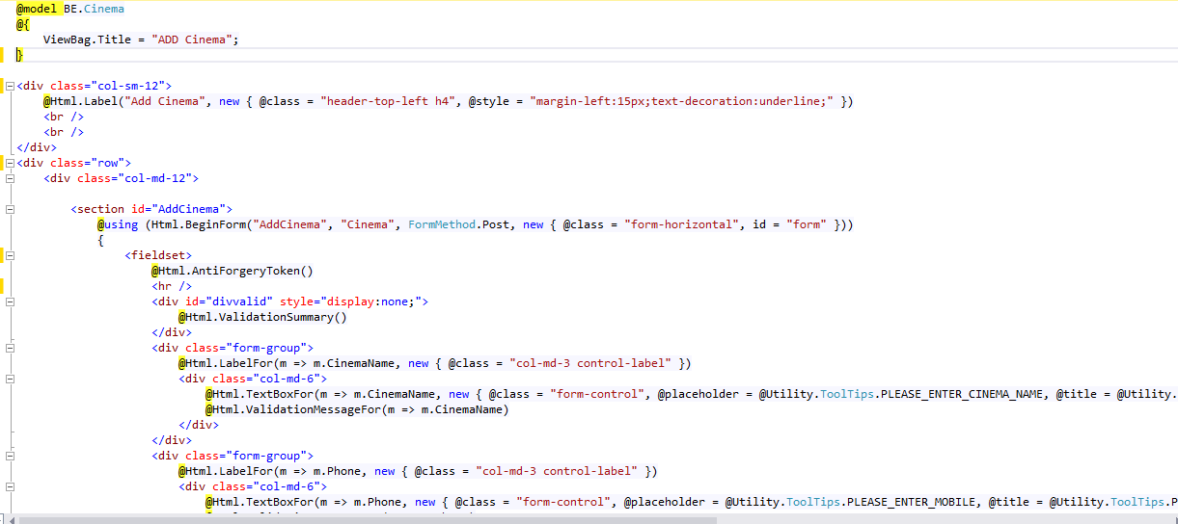

The Cinema class which is created in Business entity project, define various properties of cinema. Various validation attributes implemented, for instant, minimum length, maximum length etc.

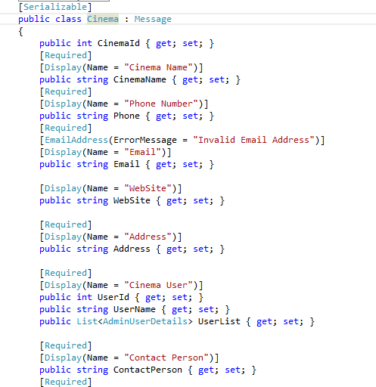

In the cinema controller, new method added which is AddCinema .

Furthermore, applied two attributes which are HttpPost and authenticateUser where httpPost is to determine whether the request is coming from httpGet or post and authenticated user authorize the user whether is eligible for adding the cinema or not.

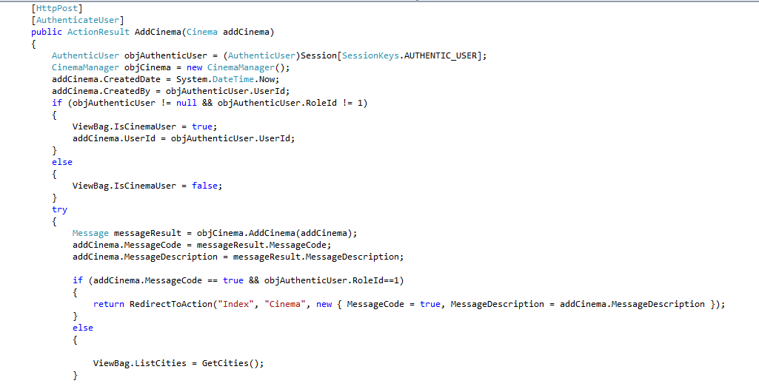

CinemaManager class’s object created which is called AddCinema method.

It will add cinema method accepts cinema class object and returns message class object.

According to message class, show success and failure notification.

In CinemaManager, AddCinema method the following code has been implemented. Figure show below, cinema class properties converted to SQL parameter list.

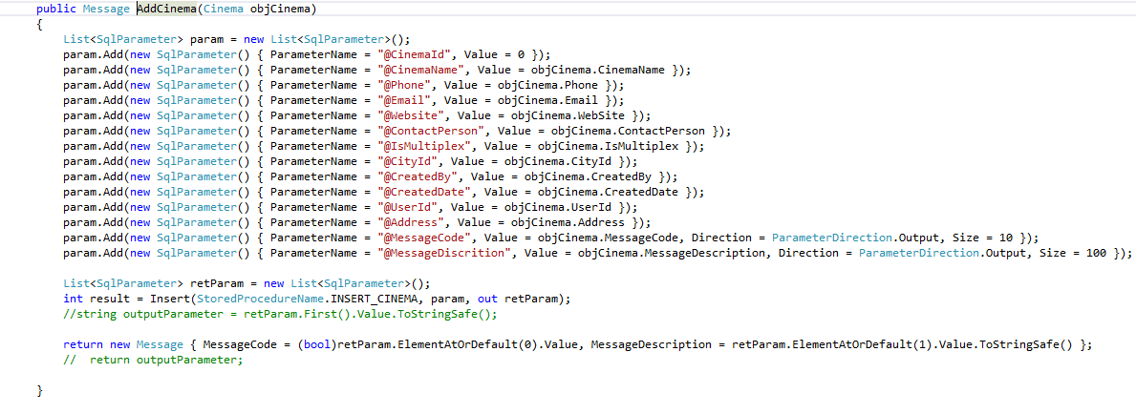All the manager class is inherited by Base Manager Class so we have some predefine classes like insert method. the same method and pass SQL parameters and stored procedure name applied which defined in stored procedure name constant class. This stored procedure has following logic, Figure show below

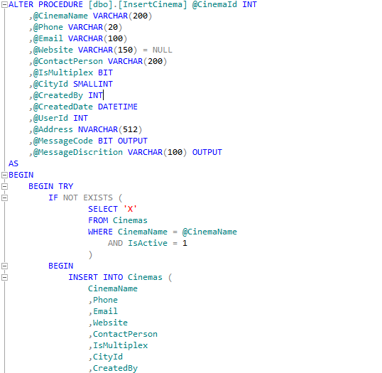

Database interaction for Add cinema

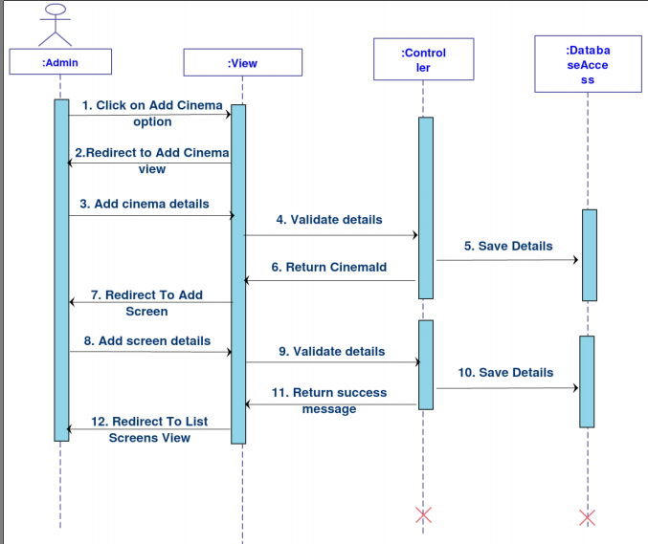

**Things I have Done Right**: great aspect about this architecture is it gives flexibility. A key feature about the design provide the user flexibility to upload the seat structure, category, and default price according to their ease by uploading text or CSV file. :

**Problems Faced**:  cinema screen was a great challenge. Due having different cinema screen layout, default pricing also different and seats might have divided in different categories. would have been satisfying to make this process easy to use as well as for end user (Cinema user or admin) can change it easily, customize it according to their need.

To do all the steps , file upload option with specific easy format implemented, which end user can follow. The user can define the number of seats, category, and default pricing in the text file with pipeline symbol separator. Once the user finished with the file, then the user needs to upload in the system.

**Improvements / Enhancements**: For improvement, could try some other view as well which might require some research and if it is better than current screen configuration screen can be implemented in the future.

## 4- Add Movie

**Description:** This use case concerns with adding of new movies and their details. The User may add movie details before due its actual release date.

**Actors: Admin**

**Basic Flow of Events:**

1- User enters details related to the movie like name, genre, language etc.

2- User adds details like show timings, cinema screens, and corresponding pricing options.

**Pre-Condition**: User must be logged in as admin.

**Post Condition**: Movie is added and changes are reflected on the website for the users to view.

**Evolution:** To Add Movie in the system is an important task as system user entirely depends on it. Movies are the main objective which the end user will book from the system, to add a new movies in the system, created a simple layout to use. The end user will search for the movie and also the user might want to know different information, for example, cast, category, director etc. the User might like to view the trailer of movie or banner of the movie which involve more users to visit the site.

**Coding:** this page has been created rather simple for the admin user, where the admin user can add the basic detail of the movie and also given facility to upload image for the movie. trailer option has been created, end user must provide only YouTube embedded URL. adding the movie, new view in Movie folder is implemented with name add.

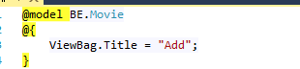

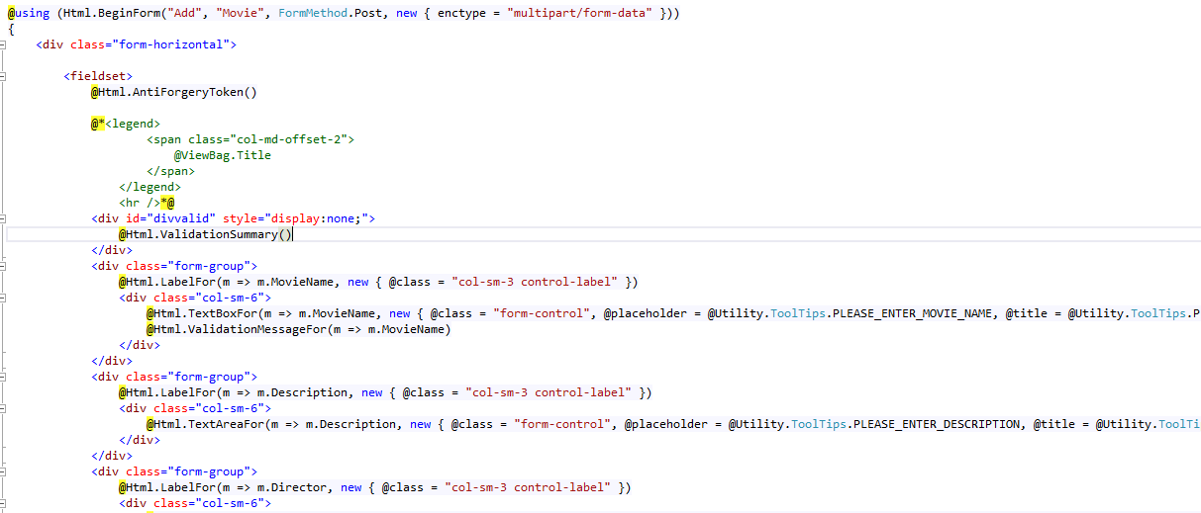

added file upload @html.fileUpload control to upload movie banner.

 In HTML tag, multipart/form-data used which is required when uploading the file from the HTML page.

 The Figure below for movie class will find it is the serializable class with different properties like max length, min length, required etc.  This attributes added for different validation purpose suppose if the person not provided movie name which is required then there should be an error message  occur on view.

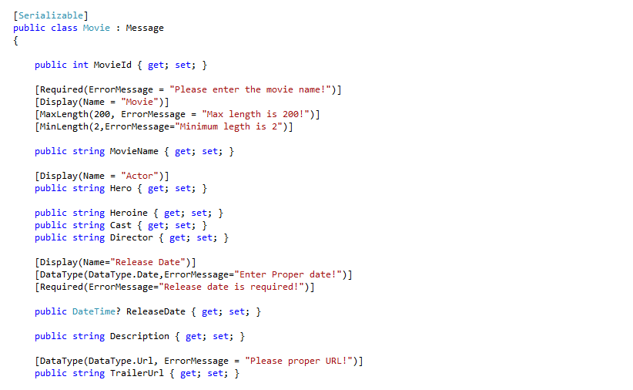

For URL data type used URL which means the provided text should be a URL and if the end user does not provide the correct URL then an error message “Please suitable URL!” will prompt.

 In the controller side, a method with HttpPost implemented. As we are uploading the file from view so I have used formcollection and httpPostFileBase parameter where formcollection is the collection of control which exists on view and httpPostedFileBase is the file which end user uploaded.

To proceed further, movie class object initialized and assigned value from formCollection according to keyname. See figure below.

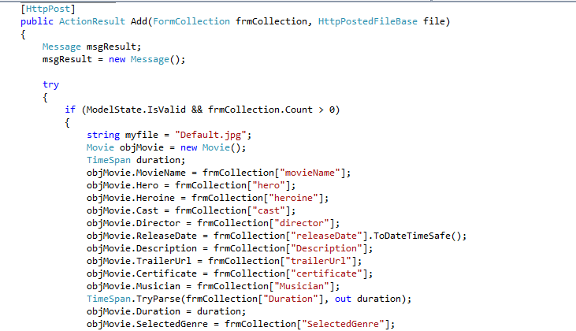

For the file firstly checking whether file uploaded or not if the file is not uploaded then will not do anything, but if the file uploaded then whether the file  length is greater than zero or not.

Once this check passed, then will determine filename then extension and then create a new path with new filename. Generally, saving the file in the images folder of the project. Once the file is saved on the disk. Keep this file name and add to movie object.

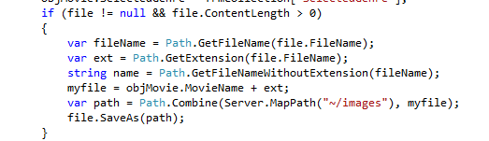

Once the movie object is created, then will pass this object to AddMovie method of Movie Manager Class.

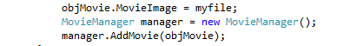

for AddMovie movie class object converted to SQLParameter List and pass it to stored procedure by calling Base manger’s Insert method. The stored procedure name is coming from StoredProcedureName class of Utility project. According to return of insert method, then show success or failure notification on screen, figure show below for SQL.

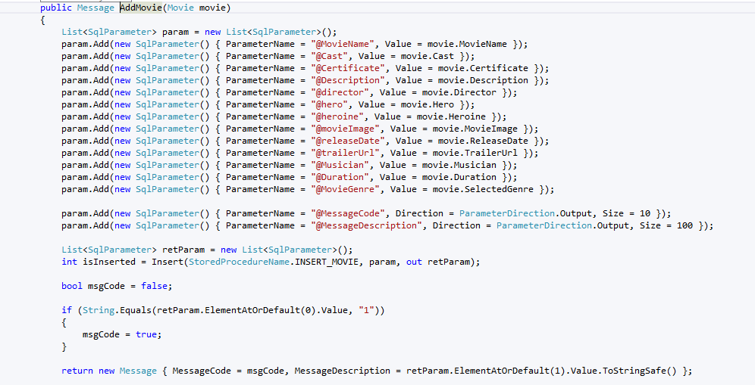

For the stored procedure of InsertMovie, adding the Movie’s field values using Insert command as well as movies categories.

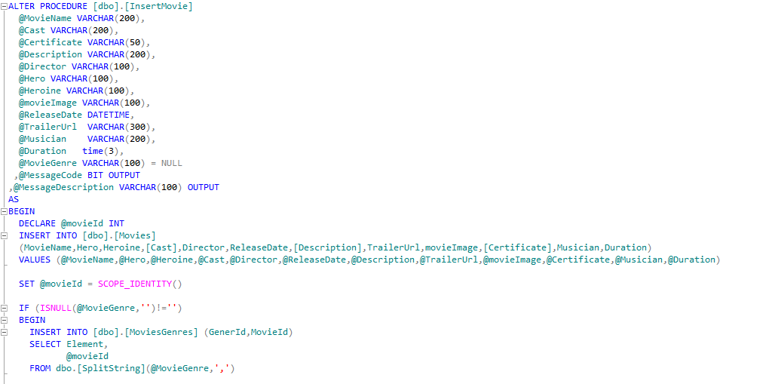

Database interaction for add movie

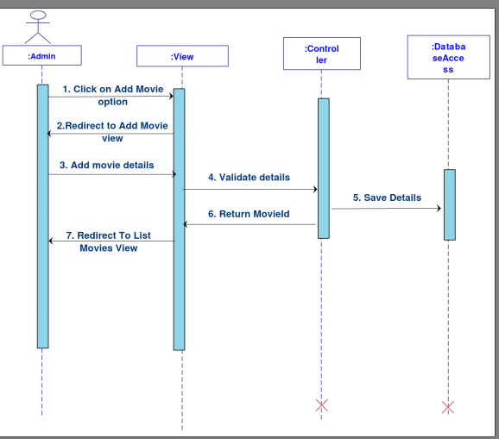

**Problems Faced:** The challenge was to save embedded video; there was not other way to embedded video for trailer directly .the only way was to do it Thought YouTube, as YouTube providing this facility, nevertheless it made it easier for developer without making a lot of effort

**Improvements / Enhancements:** For improvement better UI is one of the important points. Tab view can be used for this page where each tab has different control according to the category. The other part which did realized later on that currently in the system there is only one banner can be uploaded for each movie , to improve could have multiple banner images as it will help end user to interact more with the system.

## 5- Registration

**Description:** A user may view the currently showing and the upcoming movies, along with the show details. But in order to book a ticket user must be a registered user. This use case deals with creating valid credentials for a user and storing user’s details in the system.

**Actors: User**

Basic Flow of Events:

1- User logs on to the website.

2- User clicks on the Login option present on the top right corner of the screen.

3- Once the pop-up shows up, there’s a separate tab for registration that the user

needs to switch to.

4- After entering the details required, the user needs to verify his identity by

clicking on the link sent to him over his registered mail.

**Pre-Condition**:  The user must not already be registered in the system (i.e. the e-mail entered must not already exist).

**Post-Condition**: After successful verification, the user can now book tickets, view transaction history etc.

**Evolution**: When the project started, it was not mandatory for a user to log in. Any unregistered user could also book tickets but to accommodate the requirements and to allow only verified users to be able to use the system, this use case was brought in action.

**Coding**: Unlike the other modules of the system, this module can be accessed by any anonymous user. Moreover, in contrast to other master pages, registration module has been implemented as a pop-up. A separate mail sending utility has also been integrated with this use case which allows the system to send emails on successful registration. As it is popup, did have kept this view in shared view with “_” underscore as a starting naming convention,

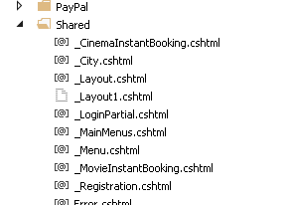

This registration belongs to End users in the cinema system project.

Customer Entity has been created in Business Entities. Customers class inherit Message class which is responsible for showing Success or failure notification.  Customers class as figure show below has different attributes like customerID , First name, lastName, Email etc. also added a couple of attributes like Display name, MaxLength, Miniumlength etc.

Customers Entity is strongly attached to customers class.  as for the design We have HTML form with all the attributes.  @textBoxFor , it does mean it will render textbox on the screen @validationMessageFor show the validation. This view has to submit button which to do a further operation.

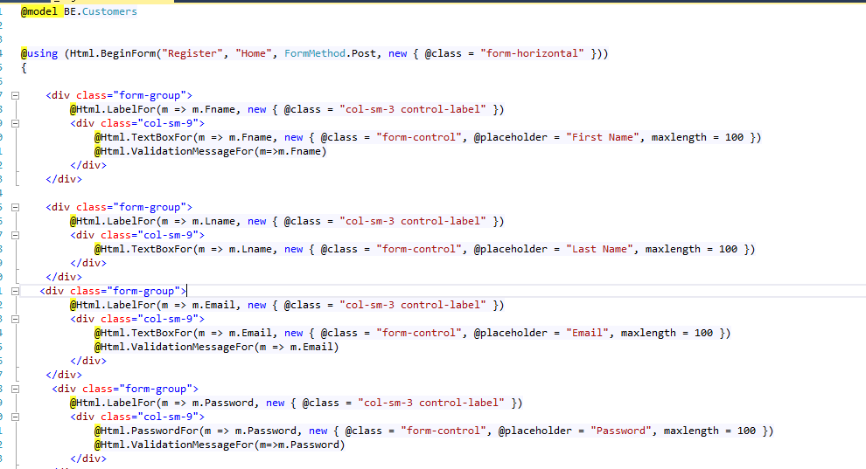

The Customers class in BE project which inherits Message class where message class is responsible for success /failure notification message. Also added different attributes, data type, data formats, max length, and min length and error message corresponding to the validation.as figure show below

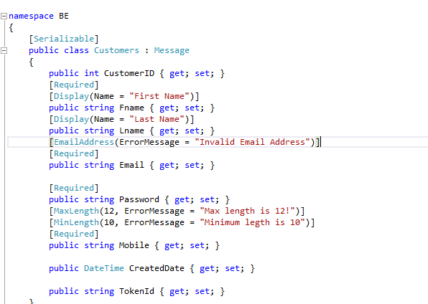

Registration is landing on home page and it is popup .

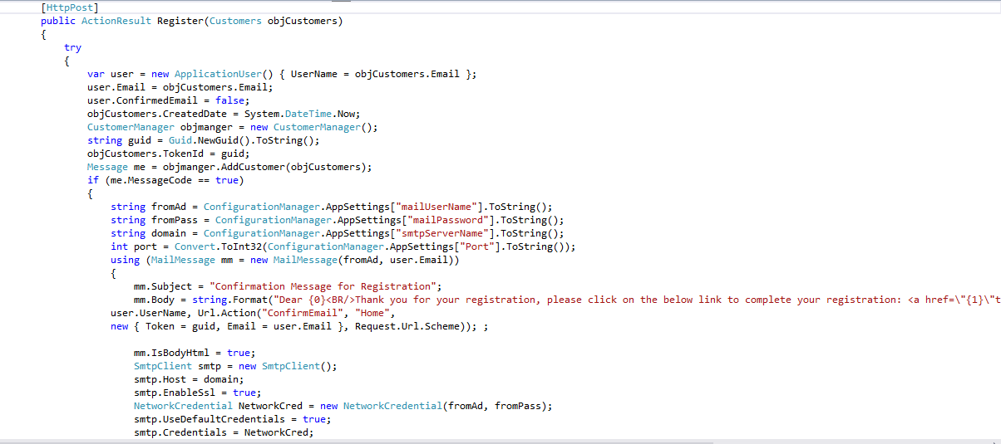

This registered method has HttpPost attributes means it can be accessible only when there is httppost event happened.

In the registration, the code has been written for creating an object of CustomerManager first. customer manager has  method AddCustomer which takes Customers object, pass the customers object in AddCustomer method as  can figure show below

Message ms = objManager.AddCustomer(objCustomers);

Where CustomerManager is returning message object which represents whether the registration is done successfully or not.

Once the message received then according to the message will go further. If the user  is registered successfully then write an email to activate an account, also, send a unique identifier to validate users  mail.

Email function is implemented which create first Email object and send the message.

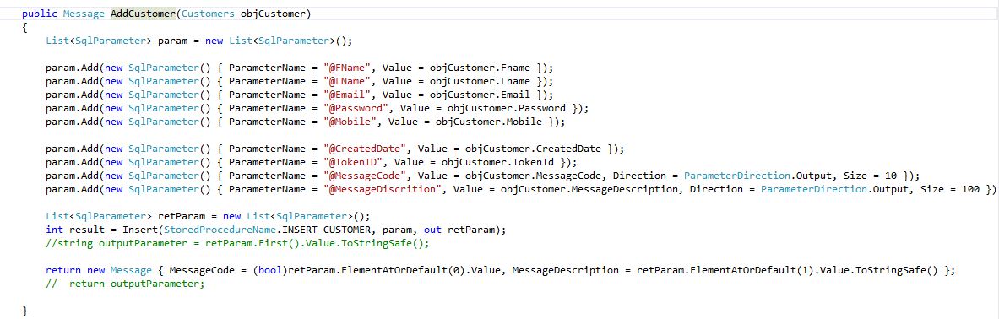

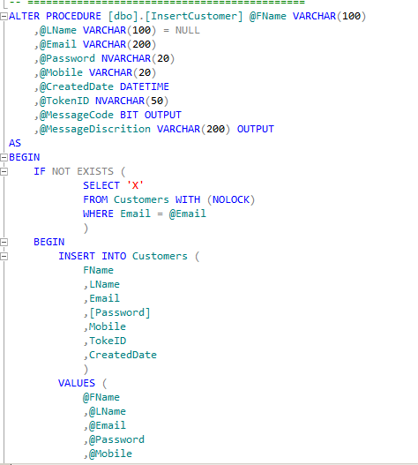As shown above Addcustomer method in Customer Manager class. SQL has been created Parameters of attributes of Customers class which is passed in parameter.

Once List of SQLParameter is created then pass this in Insert method of Base Manager. also pass stored procedure name which is mainly a constant created in Utility class’s Stored ProcedureName class.

Furthermore checked if email address already exists then the system alert user that email address is already exists. All the insert logic wrote in stored procedure as shown above.

Database interaction for user registration

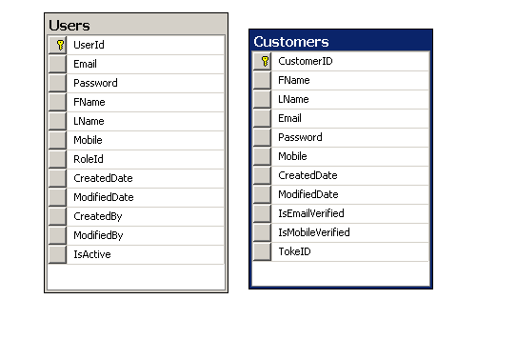

**Things I have Done Right**:  I have struggled with this user case as I couldn’t make my mind up, how to go on about doing the coding for the registration as there are many options and to make sure the verification of the user’s identity. I could have done in either three ways below as mentioned earlier in the documentation.

* Two-step authentication using OTP
* Sending a system generated password on the registered email
* Sending a verification link on specified e-mail address.

Comparing the pros and cons of each method against the other two, it was an easy decision that sending e-mail was an efficient and more convenient option than sending OTP on mobile phones. The option of verification using mail was finalized as using a system-generated password would be troublesome for the end user as the user would have to change the password on the first login. Thus, sending a verification link was the best option for this particular project.

**Problems Faced**: A major problem was the Gmail security issue. Any dummy email address that would be used to send the email would not send out an email. After researching the issue, the cause was found to be the Gmail security feature. had to make sure enable low-security mode for sending emails via apps/websites to accomplish the desired task.

**Improvements / Enhancements:**

Surely can add a new feature for example (SSO) single sign on, later on in near future if want to improve the project further

## Critical analysis

While developing any project it will come with height and low, ups and down, sometimes project fails, other times succeed it’s all down to planning will ahead and making the right decision as well as having right skills for the project,

At the beginning of the project Thought about creating a simple and very basic application from scratches, where the user can register the system, and have a login system, and simple reserve a ticket layout without going to much depth , after some research I thought wouldn’t be easy to download a ready template and change the functionalities and the style to suite the application and do all the necessary coding , that is where the issue began ( which was a massive mistake), I downloaded a free template from [https://w3layouts.com](https://w3layouts.com/) , and changed the style as well as CSS (cascading style sheet) and changed them according to the project requirements, on many occasions I thought it’s better to start all over again, as I faced many challenges during redesigning, and many hours of pain staking removing unwanted text, code, and images, below the original layout and template.

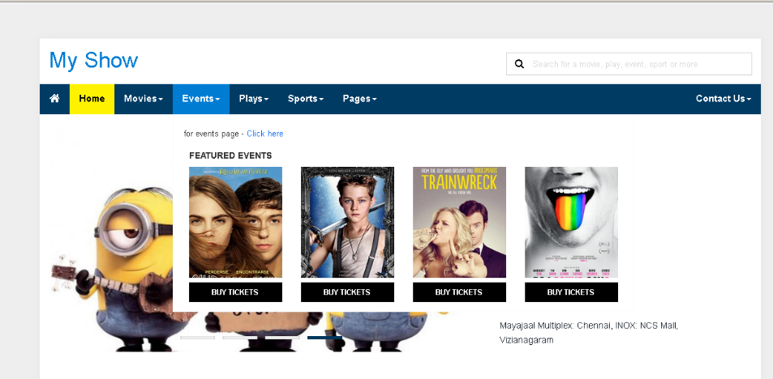

As mentioned some of the original future has been changed as it was not necessary for this project, for example in the original layout there was a page for feedback as well as contacting Us and some other pages which it wasn’t needed for the project, below is the layout, which went through some changes, below is the screen shots of current layout

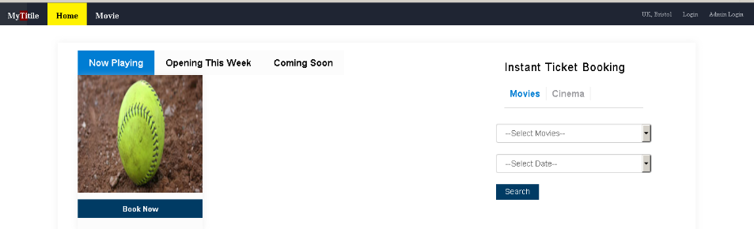

Would do things differently if I came across similar project?

Most definitely would approach the task in a different way, first of all, would plan well ahead, and secondly, leaving enough time to concentrate on documentation, not just only focusing on coding and designing the project, As a lot of mistakes has been made for the first part of submission which didn’t produced Literature review, that cost me dearly and didn’t get fine marks.

## SHNEIDERMAN’S EIGHT GOLDEN RULES:

To have consistent and to create appealing interface and user-friendly system, some of the eight golden rules and guidelines from “Shneiderman” for cinema booking system project has been implemented

### Feedback message, error message:

nowadays almost every website or application has some kind of feedback messages, it is either the feedback is some kind of form or text box, there are little messages that appear when there is an error or warning, when the user having some kind of activities or steps completed successfully, designing these messages is vital because the last thing you need is to confuse or alarm the users when there is nothing to worry about.

For this project I have implemented this rule, when the user tries to login to the system, if the user fails to login into the system for any particular reasons, for example, user mistakenly type the username or password the system will show an error message in red color that the user ID or password is not valid, this message will be visible straight way as it is in red color, and that will make the user more aware and alert that there is an issue.

Furthermore, when the user trying to choose seats, if the seats does not match the number of tickets the system will warn the user and the system will show a red error message, cannot procedure any further, number of seat(s) selected is not same as seats specified.

1. **Consistency:**

To have consistency all the way through the system, for example, size, color, the banner for all the page should be the same to avoid misunderstanding, according to Romli “Consistency interfaces let the user to be familiar with the system therefore helps them to use the system well.” So similar design and layout will help the user because they will not feel worry when the user want to use the system and understand all the functionality as well as links and buttons.

For cinema booking system, the layout, banner, footer, fonts as well as color are all the same and consistence through the project.

1. **Reduce Short-Term Memory Load:**

Cinema booking system displays in home page images they are all set to very low resolution, all the images on display and throughout the system has been lowered but still quality not compromised, so that can help and does not affect overload the system, and reduce short-term memory load, which makes the user experience more positive.

## THE THEORY BEHIND MODEL VIEW CONTROLLER

Model-View-Controller is a programming design pattern that is used to solve design problems of a rather certain specific application .Showing data to the user (and possibly handling input from the user) It is used for implementation, it is a good choice for web app the applications consist of three separate parts that enhance modularity and ease the model, view, and controller.

The main purpose of this pattern is to divide the parts into different parts namely the Model, the View and the Controller

***Model.***

.A model cannot function alone it handles data to the extend needed no decisions are made at this stage, the model specifies the information the list items should contain such as the item, price, etc. the list items that exist at a particular time

***View***

The View explains how the data should be viewed how the list should be displayed to the users In the list app the view would describe how the list is presented to the user and display the data in the models example a module that has an effect on another.

***Controller***

The Controller has logic it contains logic that updates the model and or view in response to input from the users of the app Controller consists of all the functionality of program it interacts with module and the view. The view directs them and sends the data between them, for example, our list would consist of input and buttons that one can use to delete the information they manipulate the model and send the updated data.

Model

Explain the data structure

Update the application

Controller

Contain Logic, receives updates from view

View

Explain the display unit

The view module produces HTML from the data the controller consists of the components needed for the server to work effectively for example, it thinks of the page that should be displayed it produces dynamic content and handles cookies etc. Controller consists of all the functionality of program and interacts with module and view.

The View directs the sending of data between them as needed the two thoughts that are considered whether the view interacts directly with the model or not. The first thought is the model and the view are separate and the do not interact with one another. The controller function is to gather all the data, the second thought is the controller can command the view to get data directly from the model hence the data will not be transferred to the controller the view functionality is enhanced so as to interact with the model to gather data.

***Example***

The MVC pattern is useful is a web server

* MVC pattern is useful in the following areas the model interacts with the database in an easier designs this may be directly using for example the SQL.
* The view module produces HTML from the data,

The controller consists of the components needed for the server to work effectively, for example, it thinks of the page that should be displayed and produces vigorous content

## Personal Reflection

This project has been a fun (part of it) but challenging experience from the start to the end, the amount of work required was considerably more than I first anticipated. For anyone else starting a similar project, I would suggest that the most important thing to prepare and have a good plane. This should include ideas such as what creates a successful project and how this will be measured. One part of this project which has proved more challenging than expected was the amounts of documentations as well as time constraint for basic parts of the project. Two massive mistakes I made in the beginning of the project, one, was not starting writing about literature review, which had a bad effect on first submissions marking, second was not creating a simple system and building the project from scratched. This lead to too many hours of removing and changing unnecessary text box, button, removing code and many other obstacles. If I were to undertake a similar project, I would build a simple application, just because timing wise is very limited. Overall the project has gone not so well in term of (documentation) and I believe this is due my inexperienced to handle the documentation.

## Appendix

## Test cases

Testing the test cases is the low-level testing of the application, testing individual components by physically entering the inputs and analysing the outputs

|  |  |  |  |  |
| --- | --- | --- | --- | --- |
| **Test case ID** | **Action** | **Steps** | **Expected result** | **result** |
| AD_001 | Login | 1- Open Admin Login page.  2- Enter Valid Username or Password  3-Click on "Login" button 4-Redirected to Home Page |  | Pass |
| AD_002 | Forgot Password | 1-Open Admin Login page. 2-Click on Forgot Password Link  3-Enter valid Username (Email) 4-Click on Forgot Password Button  If Username is valid Admin/Cinema user then the password will be sent to user |  | pass |
| AD_003 | Add Cinema User/ admin | 1-Open Login page.  2-Username or password  3-Cick on “Login” button  4-move the mouse profile menu and click on Add profile  5-Add profile page will open  6-Add mandatory fields on the page  7-If the username does not exist then profile will add successfully and the page redirect to profile list page with success message. | Profile will be added in database | pass |
| AD_004 | Delete Existing Cinema user /Admin Profile | 1-Open Login page  2-Enter valid username or password  3-Click on “Login button  4-you will land on profile listing page  5-Click on Delete icon on the record row which you would like to delete  6-Confirmation popup  7-Clicking on OK button will delete the record (if there is no reference in database)  8-Else screen will remain the same. | Profile will delete if there is reference of the user | Pass |
| ADD_005 | Edit existing Cinema user/ Admin Profile | 1-Open Login page.  2-Enter Valid Username or Password  3-Click on "Login" button 4- You will land on Profile List page  5- click on the Edit link of the grid record  6-You will get Edit Profiling page with all the populated values.  7-Every details can be changed apart from email details  8-Click on update button it will update all the field change corresponding to the selected user profile. and redirected to Profile Listing page  9- Success message will be showing. | Profile will be updated | pass |
| ADD_006 | List Cinema | 1-Open Login page. 2-Enter valid Username or Password 3-Click on "Login" button 4-Click on Cinema menu  5-Click on Cinema list link  6-will get list grid with all the cinema listing related to user if user is admin user then it will show all the cinema listing | List of all cinema | pass |
| ADD_007 | Add New Cinema | 1- Open Login page.  2-Enter valid Username or Password 3-Click on "Login" button  4-Click on cinema menu  5- click on Add Cinema sub menu  6- Fill all the mandatory fields  7- Click on Add Cinema Button  8- If there are no errors, data will be save in database a success message will appear on the screen  9- You will have redirected to List Cinema page  10- If there is any error, an Error message will appear on List cinema page | New Cinema will be added in the system | pass |
| ADD_008 | Delete Existing Cinema | 1-Open Login page. 2-Enter valid Username or Password 3-Click on "Login" button 4-Move the Cinema tab link. 5-Click on List Cinema option 6-Click on Delete button of List 7-Confirmation message will appear if you click ok and there is no reference of the record then record will be delete from the database  8-Grid will be referenced  9-Success message will appear on screen 10-On error or reference of Cinema with other tables error message will appear and page will remain the same | Record will be deleted | pass |
| ADD_009 | Edit Cinema | 1-Open Login page. 2-Enter valid Username or Password 3-Click on "Login" button 4-Move the mouse over "Cinema" tab link. 5-Click on "List Cinema" option 6-Click on the Edit link in the grid  7-Page will be redirected to Edit Cinema page 8-Edit Appropriate changes to Cinema details 9-Click on Edit Cinema button  10-if everything is good then record will update in database and you will get success message after redirection to List Cinema page  11-On failure you will get error message on Cinema list page |  | pass |
| ADD_010 | Manage Screen List | -Open Login page. 2-Enter valid Username or Password 3-Click on "Login" button 4-Move the mouse over "Cinema" tab link. 5-Click on "List Cinema" option 6-Click on Manage Screen Link  7-will be redirected to New List Screen page and if there is any screen related to cinema it will list over there  8-else there will be no grid | Screen related to cinema will be visible | pass |
| ADD_011 | Add New Screen for Cinema | 1-Open Login page. 2-Enter valid Username or Password 3-Click on "Login" button 4-Move the mouse over "Cinema" tab link. 5-Cick on “List cinema option”  6-Click on manage screen  7-You will redirect to new page  8-Cick on Add new link  9- you will redirect to a new page  10-provid screen name  11-Upload the layout file according to cinema screen setting by clicking upload button  12- Click on Preview button to preview and if you are satisfied with seating arrangement then click on save button  13- If value is correct the record will be save in the database you will be redirected to the list screen page  14- will get notification success message  15- Any errors then you will get warning /Error message on List Screen Page | Screen will be added for relevant cinema | pass |
| ADD_012 | Delete Screen of cinema | 1-Open Login page. 2-Enter valid Username or Password 3-Click on "Login" button 4-Move the mouse over "Cinema" tab link. 5-Click on "List Cinema" option 6-Cick on “Manage Screen” from the list  7-You will get Screen Listing grid  8-Click on the delete button against the Row which you want to delete  9-You will get notification if you select OK then record will be deleted if there is no reference of the screen with Movie  10-List will refresh  11-If no selected then record and screen will remain the same | Screen record delete from cinema screen according to choice | pass |
| ADD_013 | Edit Cinema Screen | 1-Open Login page. 2-Enter valid Username or Password  3-Click on "Login" button 4-Move the mouse over "Cinema" tab link. 5-Click on "List Cinema" option 6-Click on "Manage Screen" from list.  7-You will be redirected to a new page  8-Cick on Edit option from grid for Screen of cinema 9) Provide new structure which you want  10-Preview data  11-Save the data if it correct  12-You will get notification on List Cinema screen page | Screen related to cinema will be updated | Pass |
| ADD_014 | List Movies | 1-Open Login page. 2-Enter valid Username or Password 3-Click on "Login" button 4-Move the mouse over "Movie" tab link. 5-Click on "List Movie" option 6-You will get list Of movies in the system | List Movies | Pass |
| ADD_015 | Add New Movie | 1-Open Login page. 2-Enter valid Username or Password 3-Click on "Login" button 4-Move the mouse over "Movie" tab link. 5-Click on "Add Movie" option 6-Provide all the mandatory fields  7-upload image if require  8-Click on save button | Record will save in the database | Pass |
| ADD_016 | Delete Movie | 1-Open Login page. 2-Enter valid Username or Password 3-Click on "Login" button 4-Move the mouse over "Movie" tab link. 5-Click on "List Movie" option  6- Click on "Delete" from list.  7-You will Prompt for confirmation where you have to select OK and cancel 8-If Movie is linked with any cinema screen then there would be warning message  9-If movie is not linked it will delete from the system | Record will delete from the system | Pass |
| ADD_17 | Edit Movie | 1-Open Login page. 2-Enter valid Username or Password 3-Click on "Login" button 4-Move the mouse over "Movie" tab link. 5-Click on "List Movie" option 6-Click on Edit from list.  7-Redirect to new screen with all the prepopulated data  8-Update all the required field  9-click on the update movie button | Record will be updated in the system | Pass |
| ADD_018 | Schedule a movie in Screen | 1-Open Login page. 2-Enter valid Username or Password 3-Click on "Login" button 4-Move the mouse over "Movie" tab link. 5-Click on "List Movie" option 6-Click on Edit from list.  7-Redirect to new screen with all the prepopulated data  8-Update all the required field  9-click on the update movie button | Movie sets with the date and Time | Pass |
| ADD_019 | Edit scheduled Movie | 1-Open Login page. 2-Enter valid Username or Password 3-Click on "Login" button 4-Move the mouse over "Cinema" tab link. 5-Click on "Manage Screen" option  6- will get new page  7-Click on Schedule Movie page  8-will get show time page  9-Select the Movie with date and Time schedule grid from calendar in the center 10- will redirect to new page Manage show with pre filled data  11-Select end date, end time provide rates according to screen category  12-Provide all the mandatory information  13-Click on Save Event  14-Record will save in database you will redirected to previous page and get notification message | Movie schedule will be redefine in the database | Pass |
| ADD_020 | Delete Scheduled Movie | 1-Open Login page. 2- Enter valid Username or Password 3-Click on "Login" button 4-Move the mouse over "Cinema" tab link. 5-Click on "Manage Screen" option  6-will get new page  7-Click on Schedule Movie page  8-will get show time page  9-You will get context menu to delete the movie, the Movie with date & Time schedule grid from calendar in the center  10-if movie is not booked then it can be delete 11-You will get notification mail | Movie schedule will be deleted if it is not re-designed | pass |

|  |  |  |  |  |
| --- | --- | --- | --- | --- |
| **Test Case ID** | **Action** | **Steps** | **Expected result** | **Actual result** |
| UM_001 | Registration | 1-Open Home Page 2-Select city will popup 3-Click on Login menu 4-Popup will appear. 5-Select registration page 6-Provide all the mandatory information  7-If user not already exist and values are valid 8-Click Save & Continue button  9-An email will be sent to User to verify his/her email (If email configuration is done correctly)  10-User will login to his /her email account and click on the link to validate his email | User Will be save in system and a validation email sent to user by click it user will be validated in system and able to login in the system | Pass |
| UM_002 | Login | 1-Open Home Page 2-Select city from drop down 3-Click on "Login" menu 4-Provide proper username & password combination 5-Click on "Submit" Button 6-Valid user will login into system and welcome name will appear. | User will login in to system | Pass |
| UM_003 | Forgot Password | 1-Open Home Page  2-Select city from drop down  3-Click on "Login" menu  4-Click on forgot password link  5-Provide valid email or username  6-user will get password if the user is valid | Password will be available at users email | pass |
| UM_004 | Change Password | 1-Open Home Page 2-Select city from drop down 3-Click on "Login" menu 4-Provide valid username & Password 5-Valid login will get change password menu 6-Click on Change password menu  7-Provide new password and re password  8-Click on submit button  9-If password updated then notification message will appear | Password will change successfully. | Pass |
| UM_005 | Change Profile | 1-Open Home Page 2-Select city from drop down 3-Click on "Login" menu 4-Provide valid username & Password 5-Once proper login will get change Welcome your name in menu 6-Provide required value  7-Click on update button  8-Data will be updated in the system | Profile data will be updated successfully | Pass |
| UM_006 | Check Transaction History | 1-Open Home Page 2-Select city from drop down 3-Click on "Login" menu 4-Provide valid username & Password 5-Once login will Transaction history in menu appear  6-click transaction history menu it will show grid which contains all the transaction so far user have made | Transaction history will appear if available | Pass |
| UM_007 | Search By Cinema | 1-Open Home Page 2-Select city from drop down 3-Click on "Login" menu 4-If not register then register if register then provide valid username & Password 5-Click on Cinema option home page 6-Select cinema name & Date from drop down 7-click on search button  8-Will get show detail page where user will find dates and movie show time detail  9-click on Dates to navigate on different dates 10-Click on Movie time to book movie | Cinema show details will appear | Pass |
| UM_008 | Search by Movie | 1-Open Home Page 2-Select city from drop down 3-Click on "Login" menu 4-If not register then register if register then provide valid username & Password 5-Click on Movie option home page 6-Select Movie name & Date from drop down 7-click on search button  8-Will get Movie detail page  9-will find date and cinema & time click on time slot to book movie of cinema to navigate on different dates  10- Click on Movie time to book movie |  | pass |
| UM_009 | Book Ticket |  |  |  |
|  |  | 1-Open Home Page 2-Select city from drop down 3-Click on "Login" menu 4-If not register then register if register then provide valid username & Password 5-Click any option mentioned in the above cases 6-You will get book movie ticket page  7-Select no of ticket in drop down  8-select seat from layout if it is vacant then after click it would change color  9-once you finalize the seats amount will be reflecting just above the proceed button 10-if seat is not selected then then you will get error notification  11-if no of seat selected from layout and no of seat selected from dropdown is not correct then you will get notification message 12-If everything is correct then on proceed button you will have redirect to PayPal 13-Once you made payment you will be redirected to confirmation page as well.  14-if not paid then you will be redirect to other notification page |  |  |
|  |  |  |  |  |

## System development approach:

The System was developed using rapid development strategy, after finding the all the requirements for the project , the next phases was to analysis the requirements, furthermore moving along to another requirements once one requirement completed.

Rapid is iterative and increment agile methodology for managing software projects or application development.

## Management documentations

## 

IMAT3451 Final Year Project Periodic Progress Report (PPR)

Programme/Course Title:

Name: karwan kadir Assessment Period: 17/02/2016 to 16/03/2015

Project Title: cinema system Report Number:1

______________________________________________________________________

Objectives for Period: (refer to previous report)

Development period

Begin writing documentation

Summary of Progress for Period: (identify evidence of progress)

Still working on project Development

Problem Areas and Suggested Solutions:

________________________________________________________________________

Objectives, Deliverables & Plan for Next Period:

Fully working project

Near completion of documentations

Date of Next Review: 16/03/2016

________________________________________________________________________

Student’s Signature: k.kadir Date:17/02/15

Comments (if any):

IMAT3451 Final Year Project Periodic Progress Report (PPR)

Programme/Course Title:

Name: karwan kadir Assessment Period:16/03/2016 to 13/04/2015

Project Title: cinema system Report Number:2

Objectives for Period: (refer to previous report)

Development period and coding the project

Summary of Progress for Period: (identify evidence of progress)

Development and coding the project completed

Problem Areas and Suggested Solutions:

Issue with some bugs during debugging the project

____________________________________________________________________

Objectives, Deliverables & Plan for Next Period:

Working on documentation

Introduction, use cases, critical analysis

Date of Next Review: 13/04/2016

____________________________________________________________________

Student’s Signature: k.kadir Date:16/03/15

Comments (if any):

IMAT3451 Final Year Project Periodic Progress Report (PPR)

Programme/Course Title:

Name: karwan kadir Assessment Period:13/04/2016 to 25/04/2015

Project Title: cinema system Report Number:3

______________________________________________________________________

Objectives for Period: (refer to previous report)

Working on five use cases

Technical description for all five use cases, along with critical analysis

Application of theory

Evolution of main components

Summary of Progress for Period: (identify evidence of progress)

Five use cases produced

Technical description for all five use cases,

Along with critical analysis produced

Application of theory produced

Problem Areas and Suggested Solutions:

Issue with Documentation as required more formal academic writing, get help through CELL

______________________________________________________________________

Objectives, Deliverables & Plan for Next Period:

Project completion

Date of Next Review:

______________________________________________________________________

Student’s Signature: k.kadir Date:13/04/15

Comments (if any):

## User Manual:

1. Home page: This is first screen where end user have to select the city.

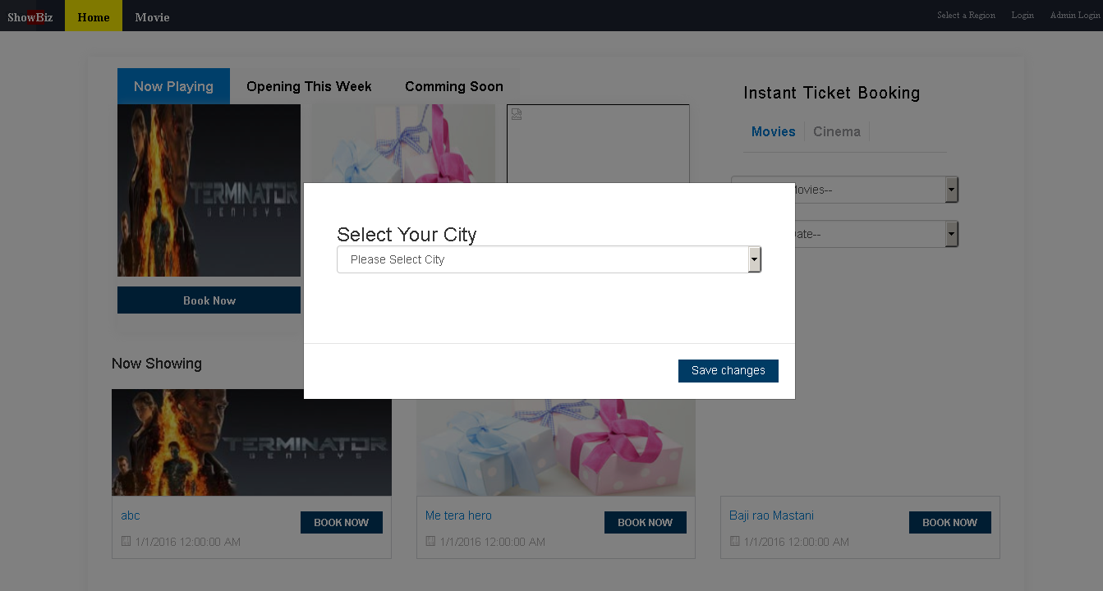

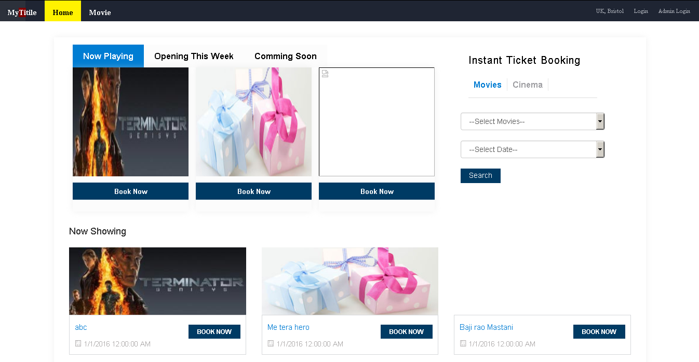

Selected city

1. Once the City selected you will find below screen
2. Can login to admin area by clicking Admin Login.



Admin Login

1. Admin login screen where admin user have to provide valid username and password to access the system

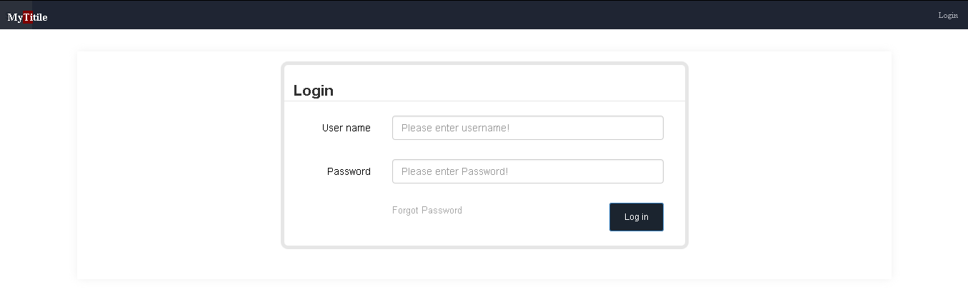

1. 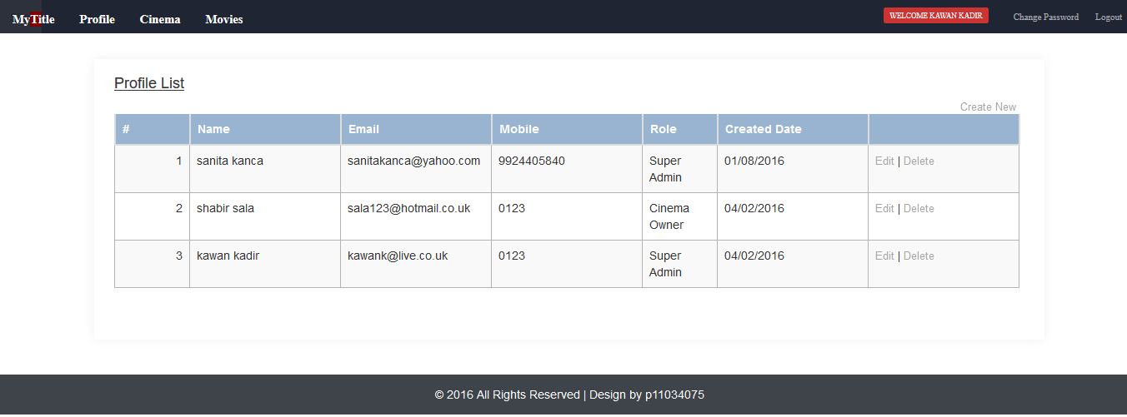Once Admin user provided valid Email and password, will get following screen. User would be able to change their profile

Person name who logged in

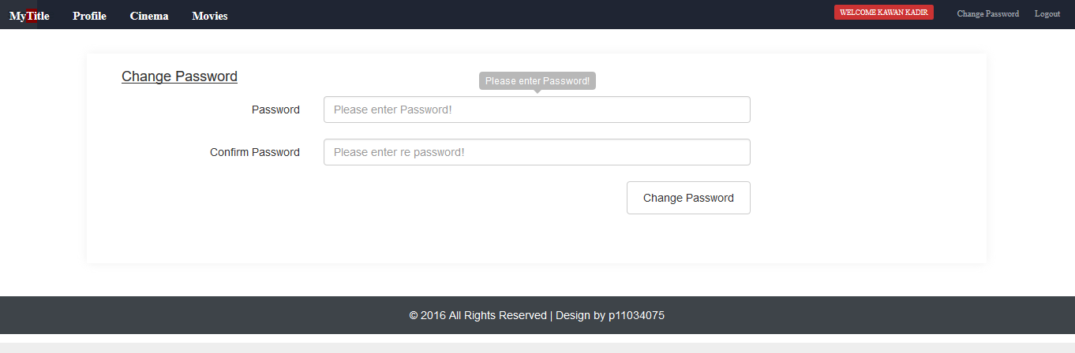Admin and end user would be able to change Password: With the help of change password button you can change your password.

1. Admin can add system users and view users by clicking profile menu in menus bar. When click List profile, will get following screen



You can add user by clicking create new

Admin can add new user (either Cinema user or Admin user) by clicking Create New as shown above or from menu

Add new profile : There are various validation applied on this page like require field unique username etc.

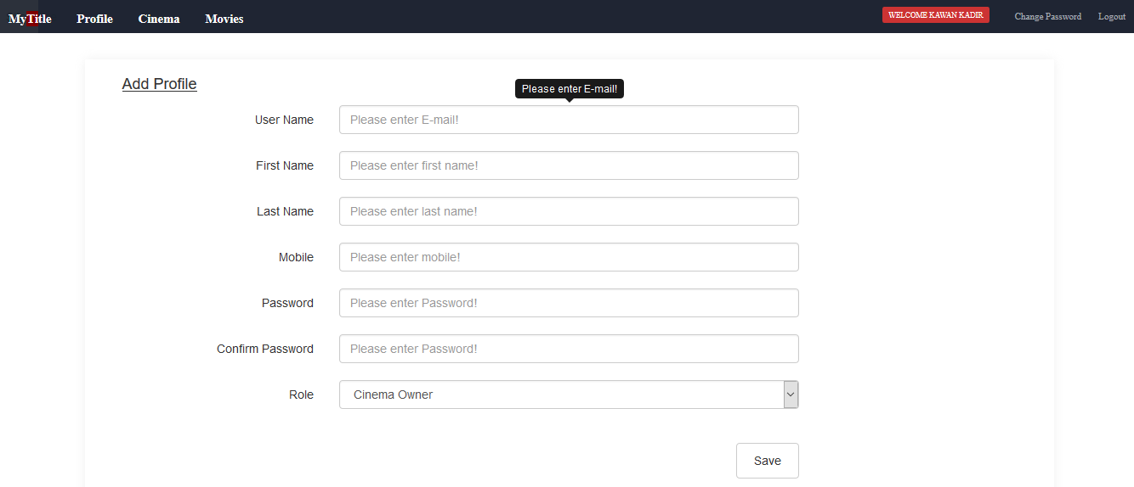

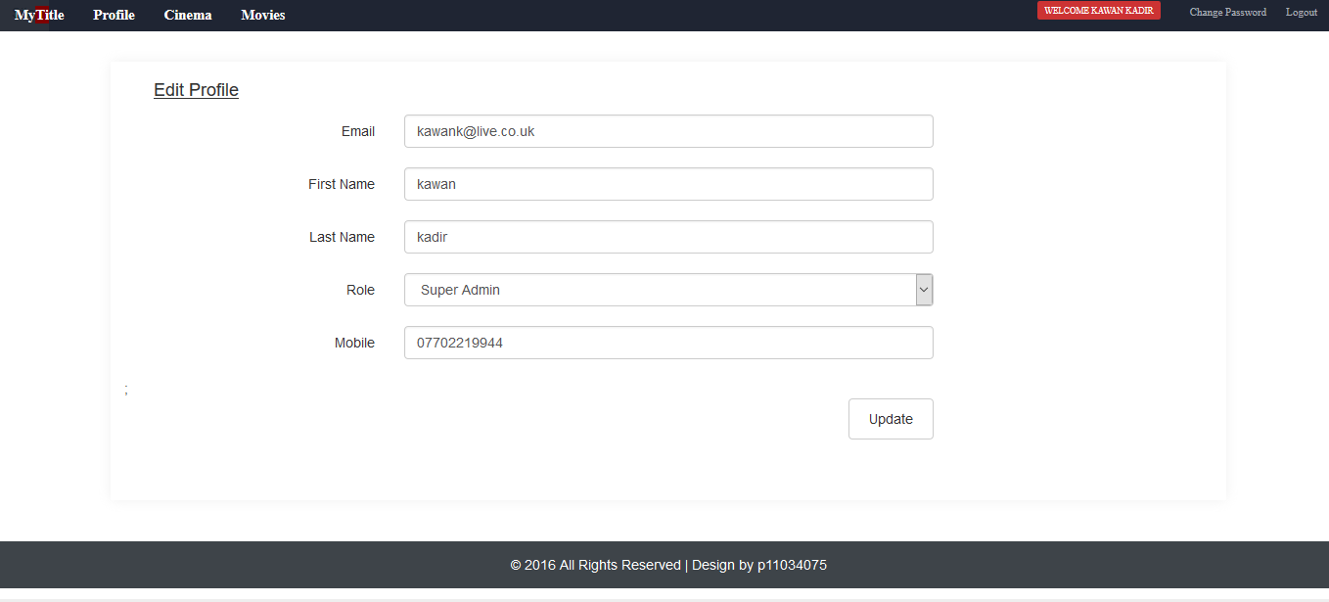User can edit the existing profile from List profile page’s edit option in the grid

User can delete the existing profile by clicking delete option in the profile grid as shown below, will get prompt as shown figure below. by pressing OK and if there is no reference of the users then it will delete and you get success message else you will get warning message.

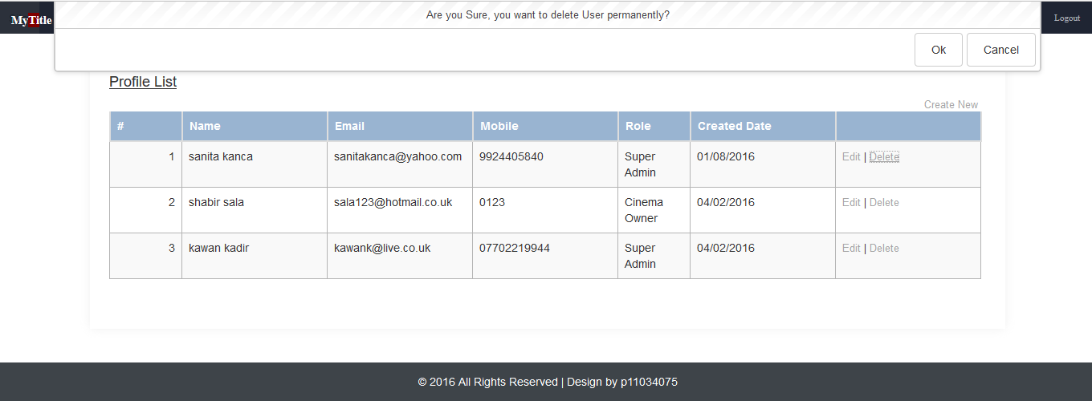

Admin can view Cinema List by choosing the List Cinema option from menu

Manage screen to manage different screens of a cinema

Delete

Add new cinema

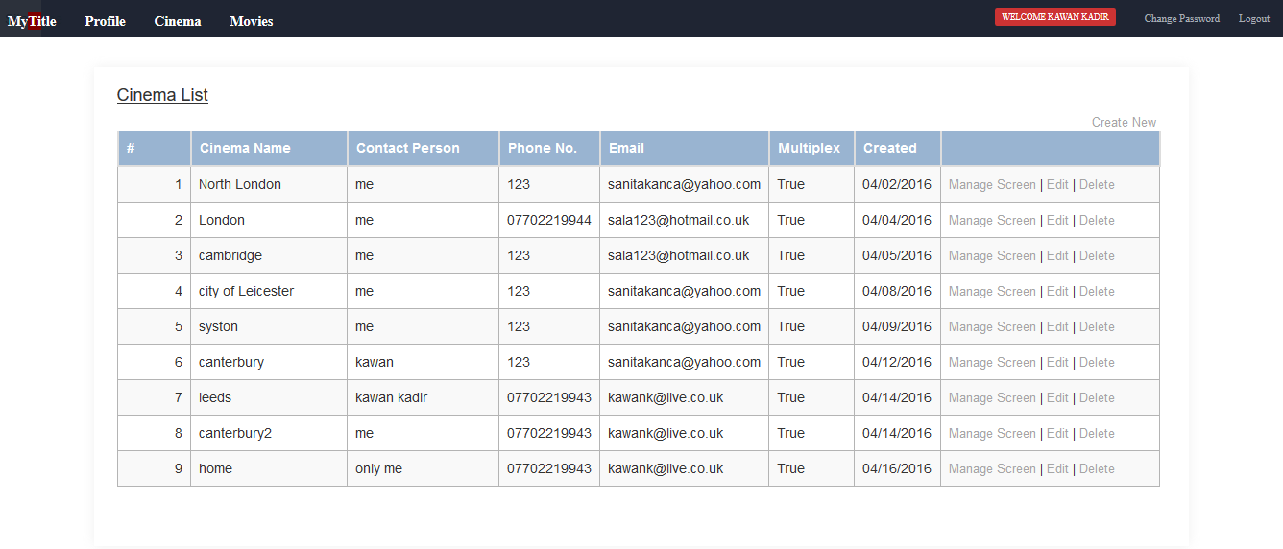

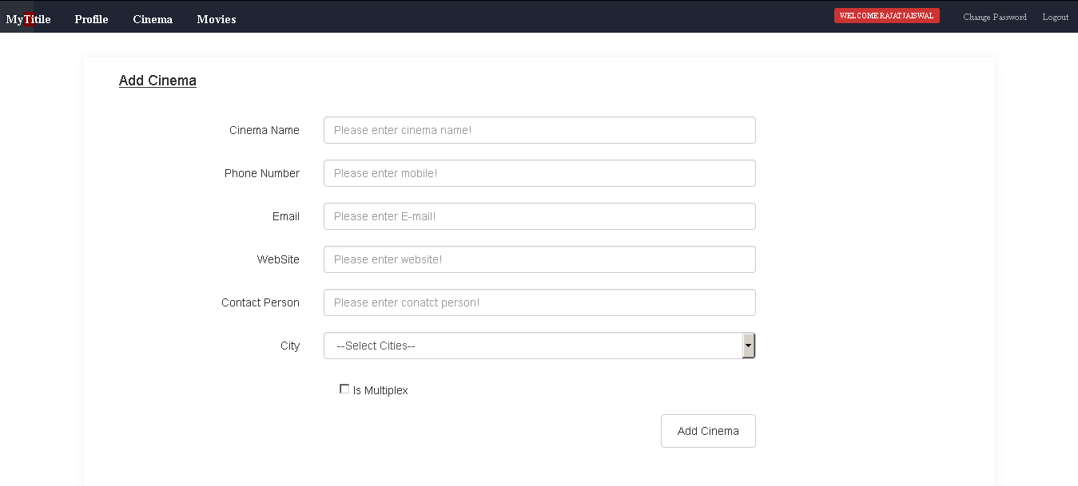Admin can add new cinema by create New or Add Cinema option from menu

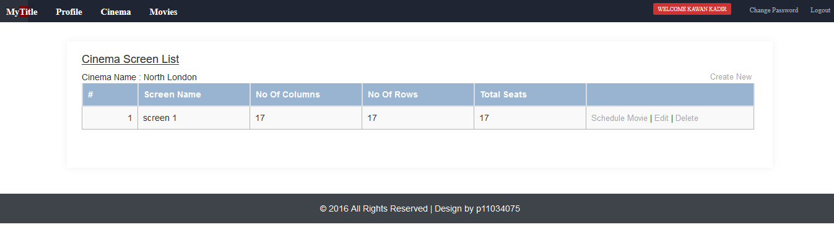Admin can manage screen of the cinema by clicking Manage screen option in the grid. Clicking Manage screen you will get following screen

Admin can add more screen by create new

Manage movies by clicking schedule movie option

Clicking the add screen, will get to following screen

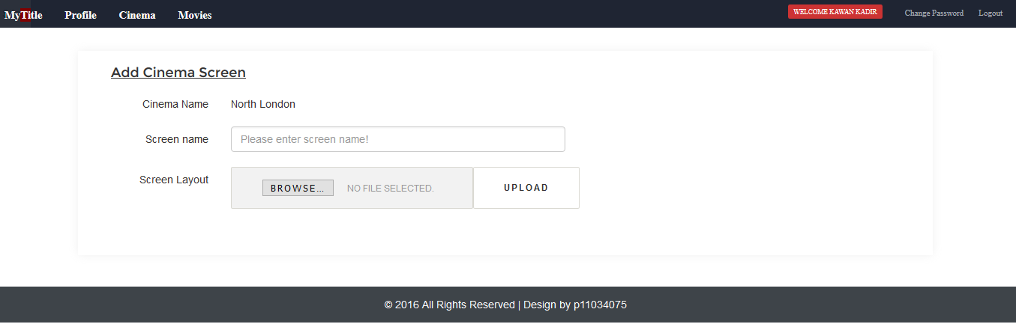

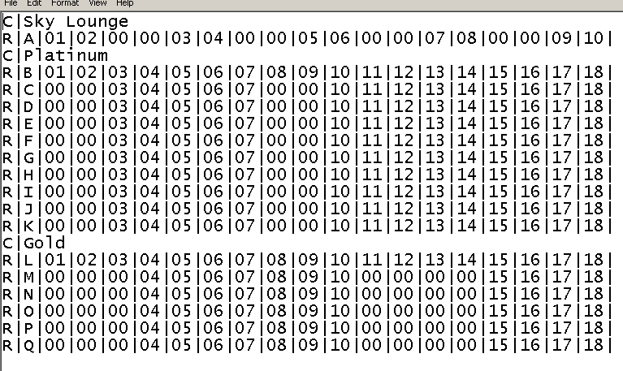Admin has to upload the layout of the screen in specific csv format as shown below

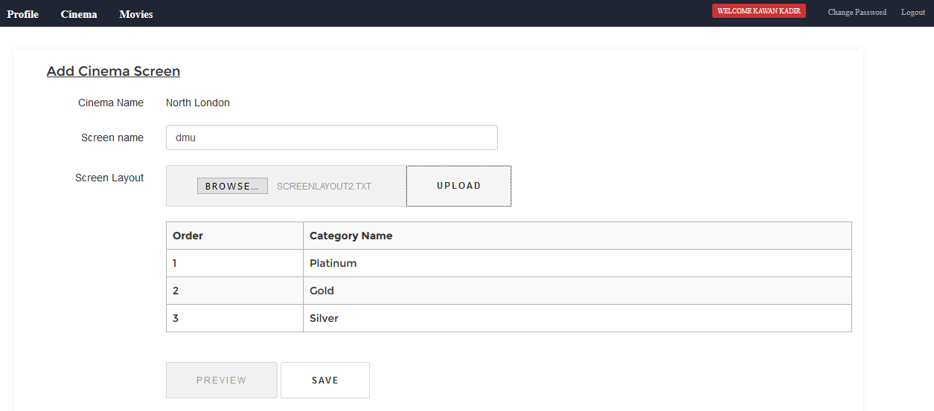When the layout upload it, will get the following screen

The payout can be previewed it by clicking preview screen as shown in above screen

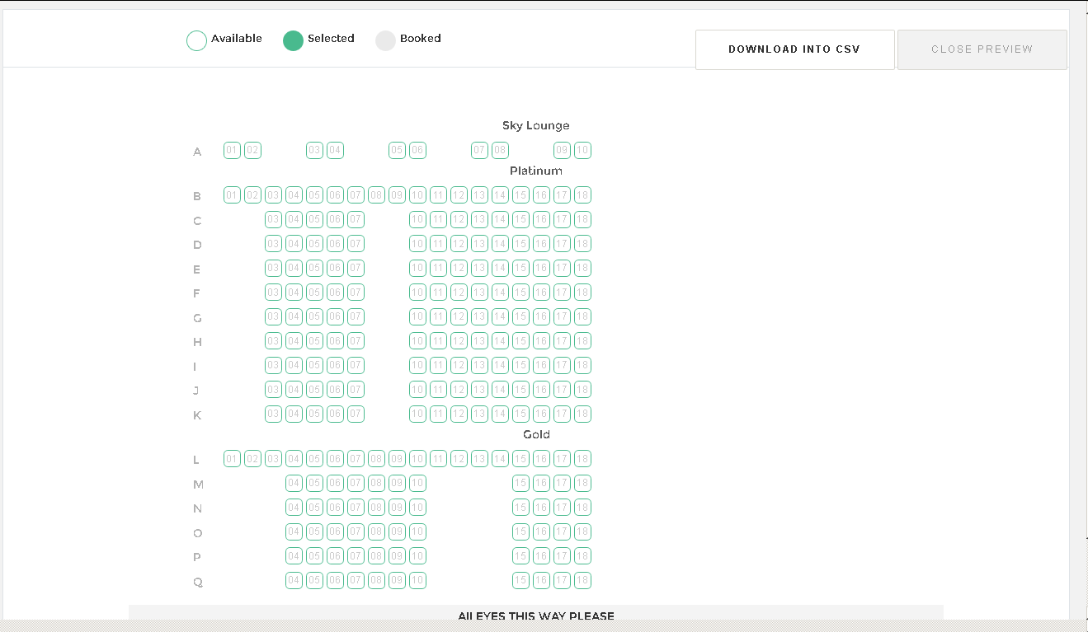

The screen has been added successfully, figure shows below.

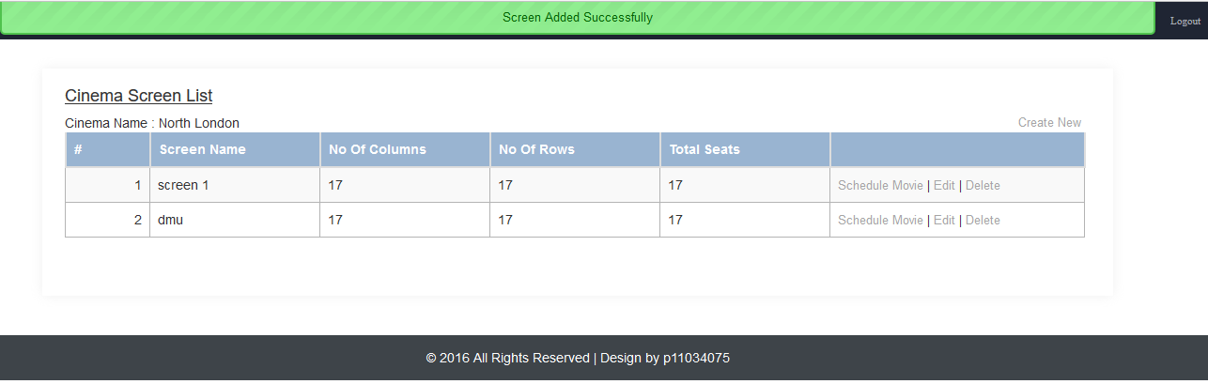

Once the screen is added admin can schedule the movie by clicking Schedule Movie option in the grid as shown above. will get following screen , and then click on any date time slot

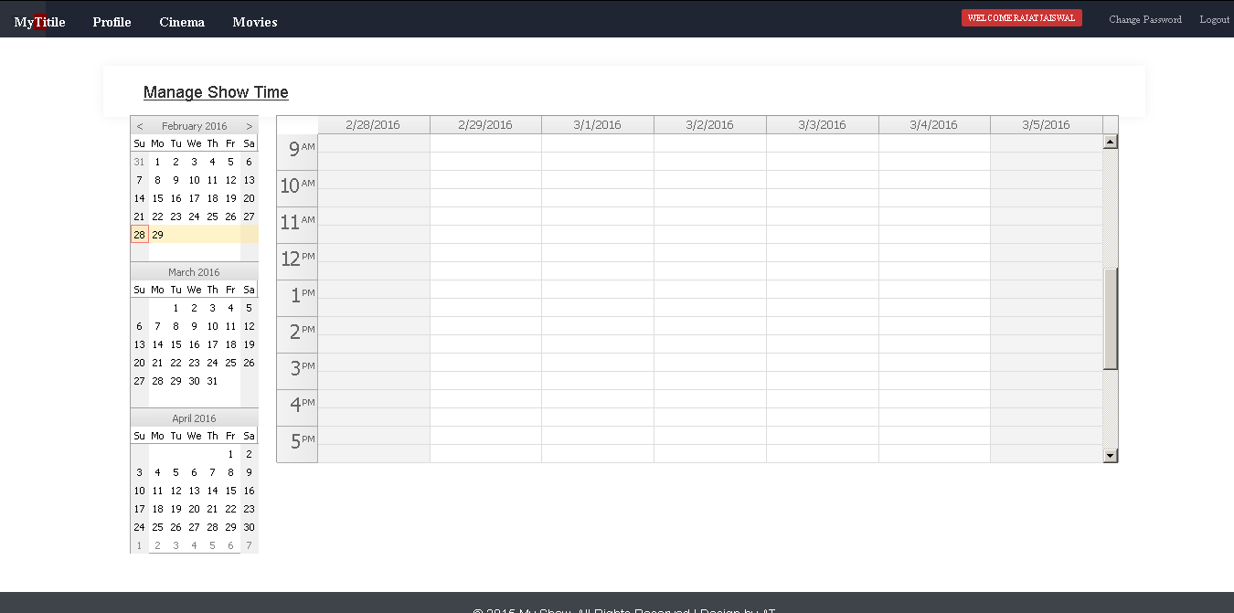

Click this area

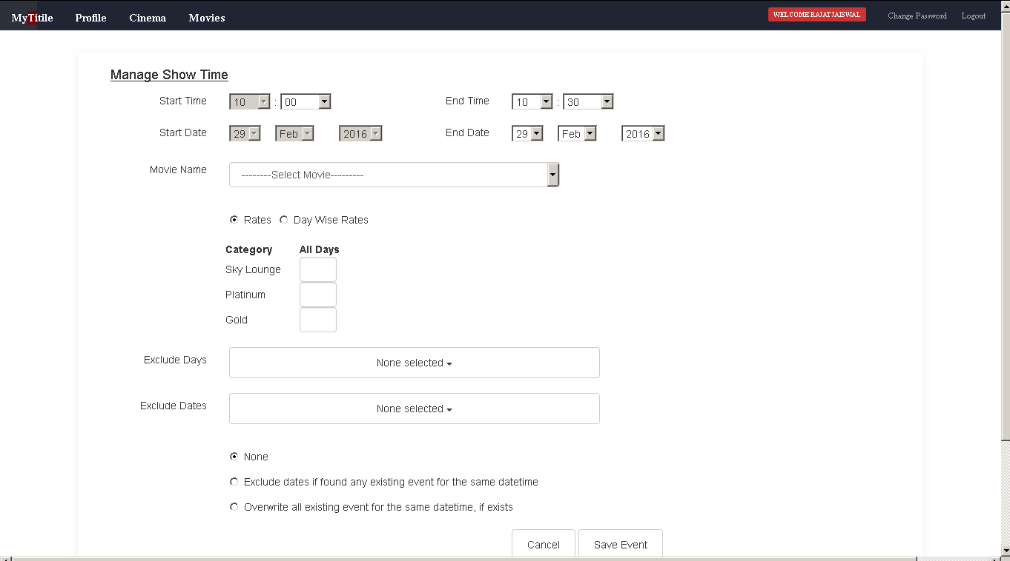By clicking around a calendar area will get the following screen. Define the show date and time, Rates according to seating category.

Assign exclude day or exclude date if any

Assign price according to seating category

Select the movie

Choose start Date time & End date & time of the show

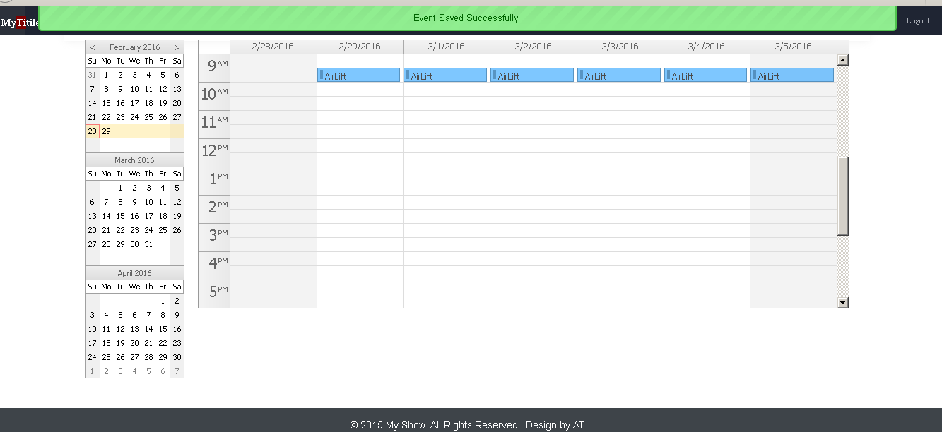Once all mandatory field completed, save the event by clicking Save Event button you will get following screen.

Movie saved for particular date time event

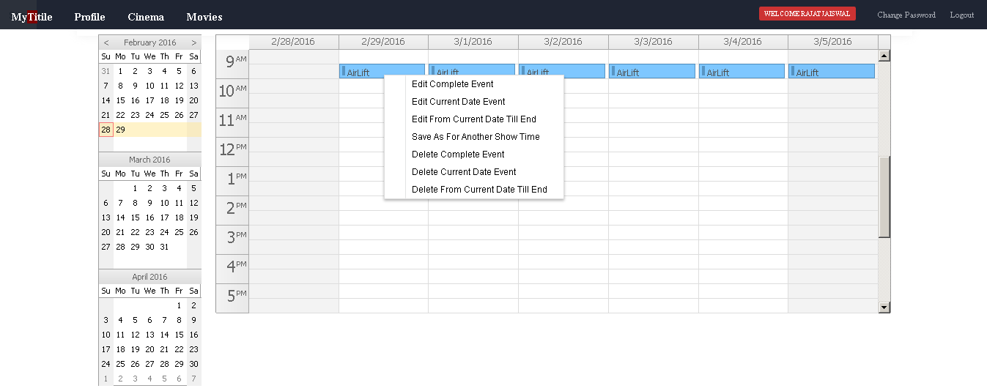Admin can edit existing schedule by right clicking the

Admin can View existing movies by List Movie page from Movie menu

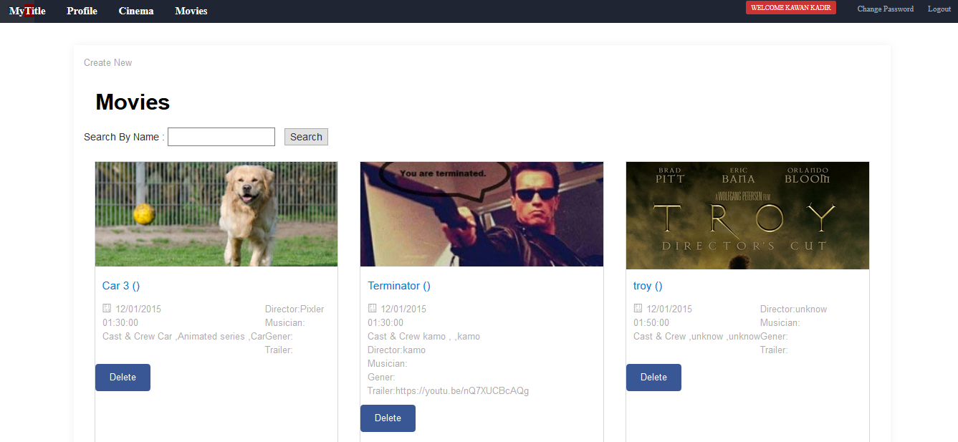

Movie can be edit by clicking the image or movie name for edit

Movie can be deleted

By clicking on the image, will get following screen:

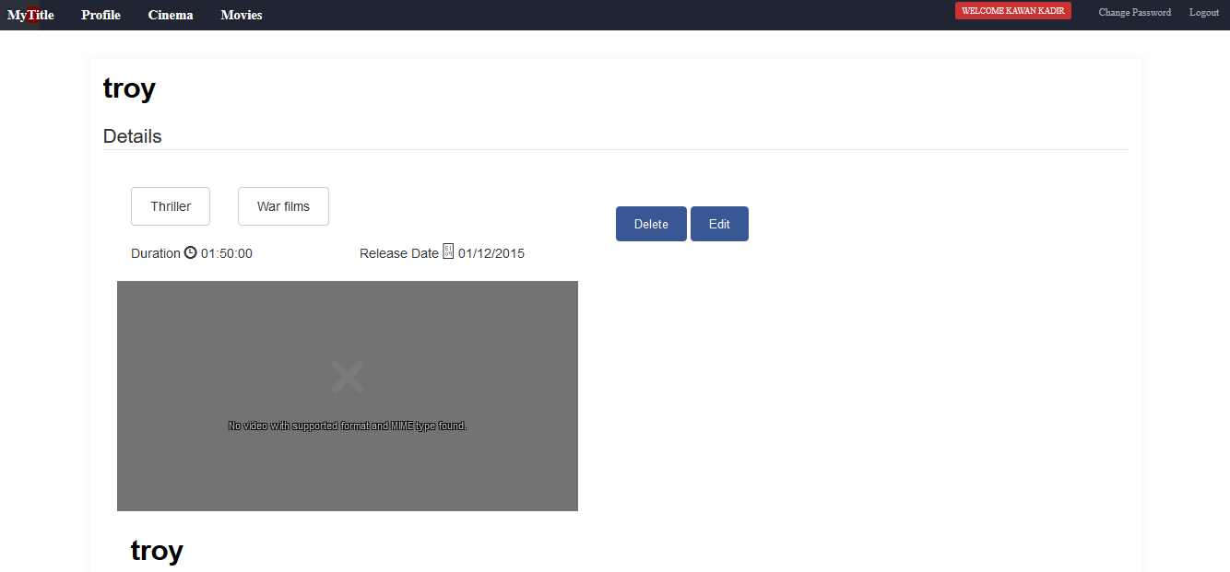

Click here to edit

Will get following screen by clicking Edit option.

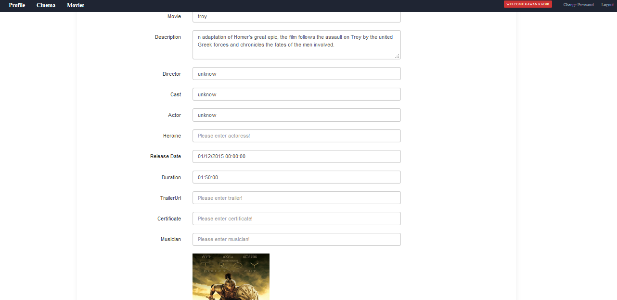

End user can edit profile by clicking on the name in the menu

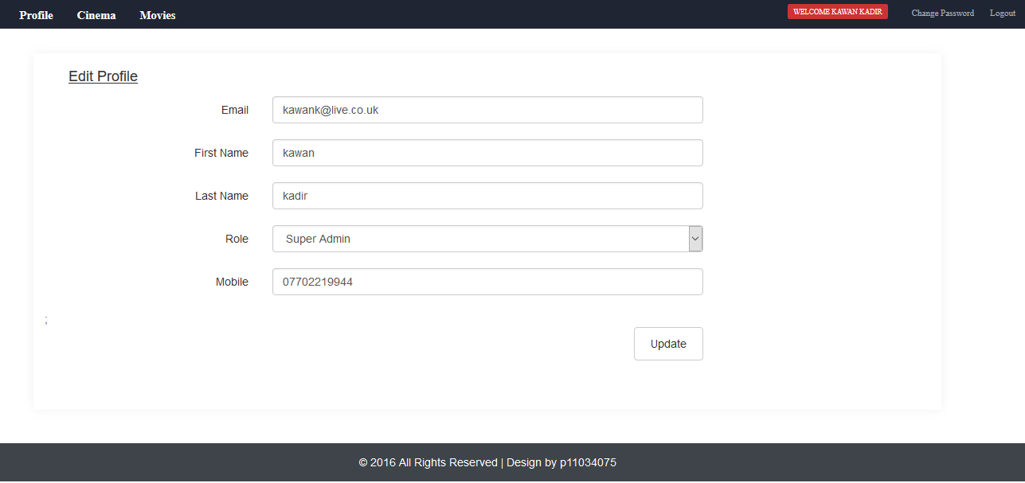

Click to edit profile

User can change existing password by clicking Change password in the menu

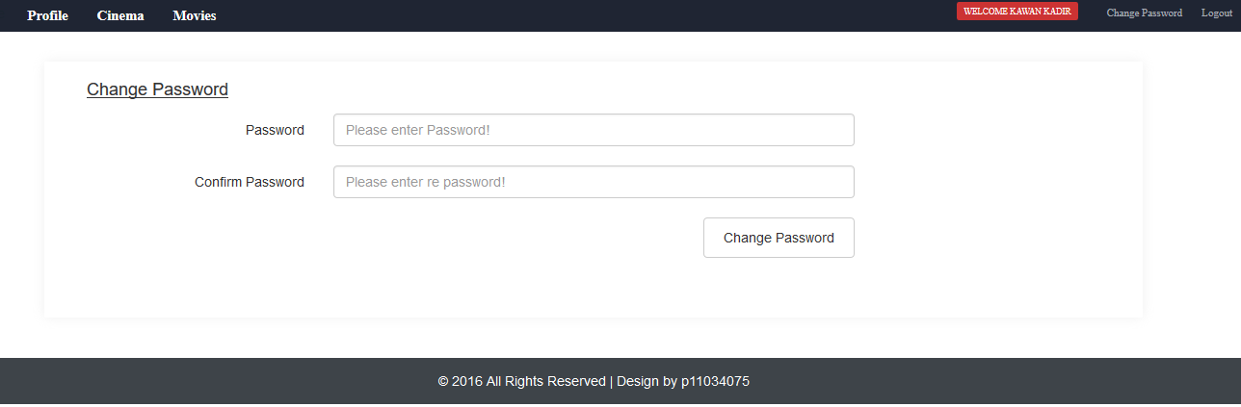

User Can logout by clicking logout button.

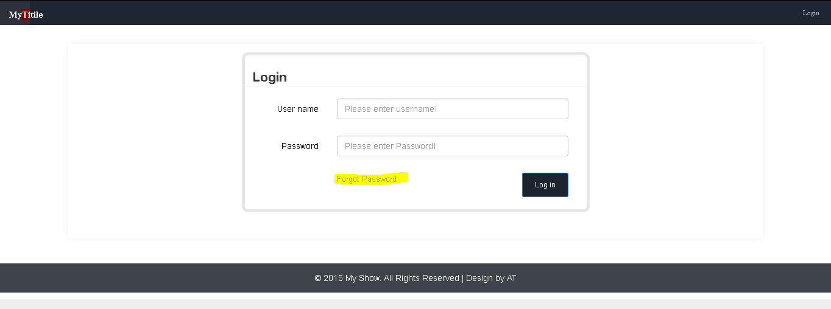Forgot the password, user can recover by click on forgot password link on login

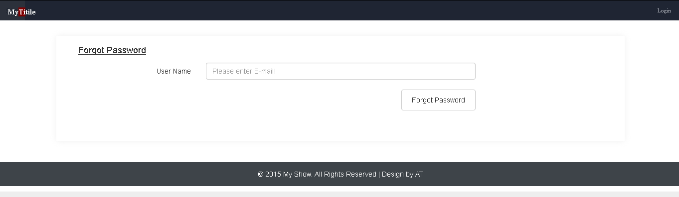Clicking on forgot password will provide the following screen

On the home page, there are different option to book ticket by clicking Book Now button or user can search movies and cinema.

Search movie or cinema

Book ticket by clicking Book button

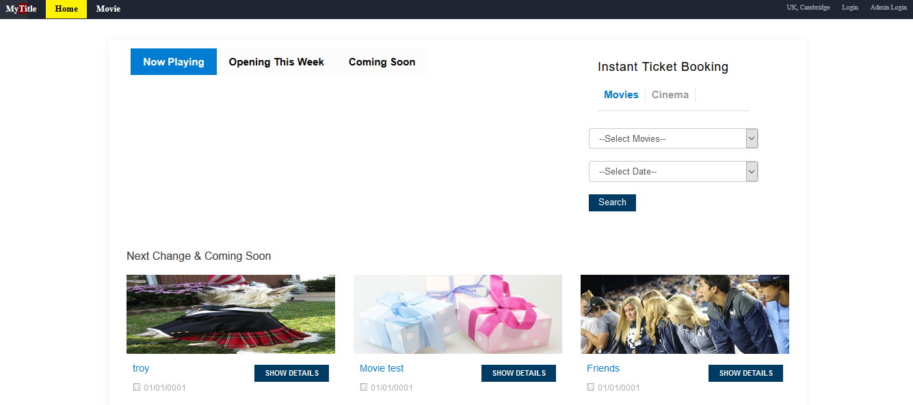

When user click on image of movie, will get following screen

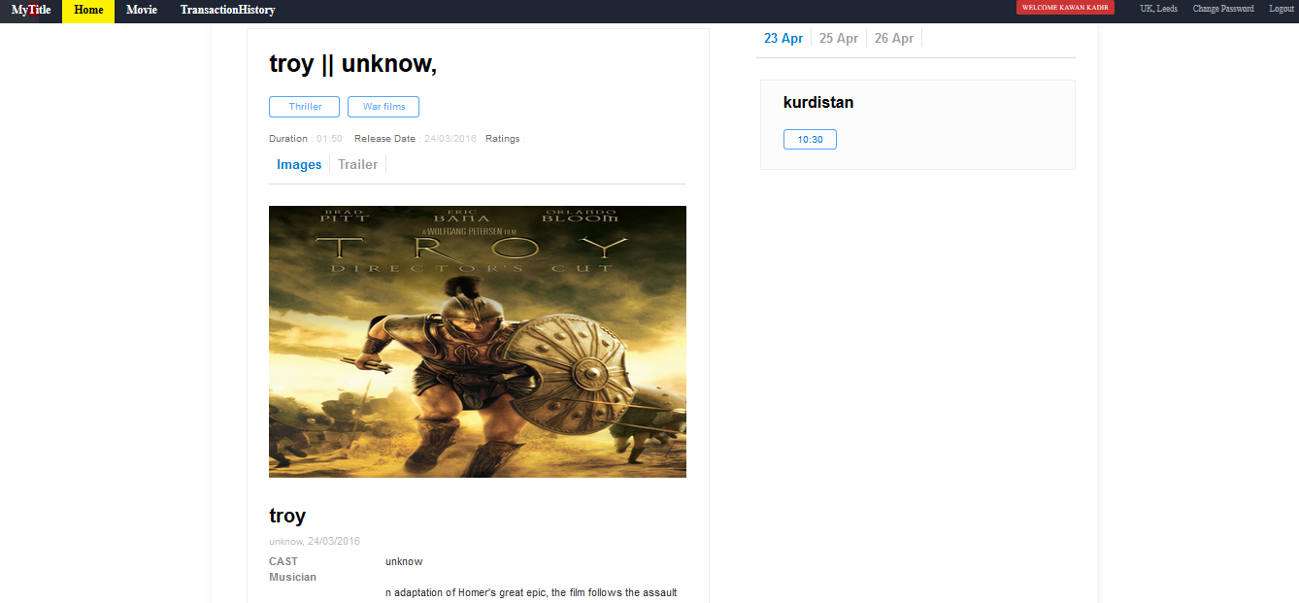

Time of the show

Cinema name

Different dates

when clicking on the show time, will get following screen

Movie name, date time and screen name

No of tickets

Choose the seats by clicking seats

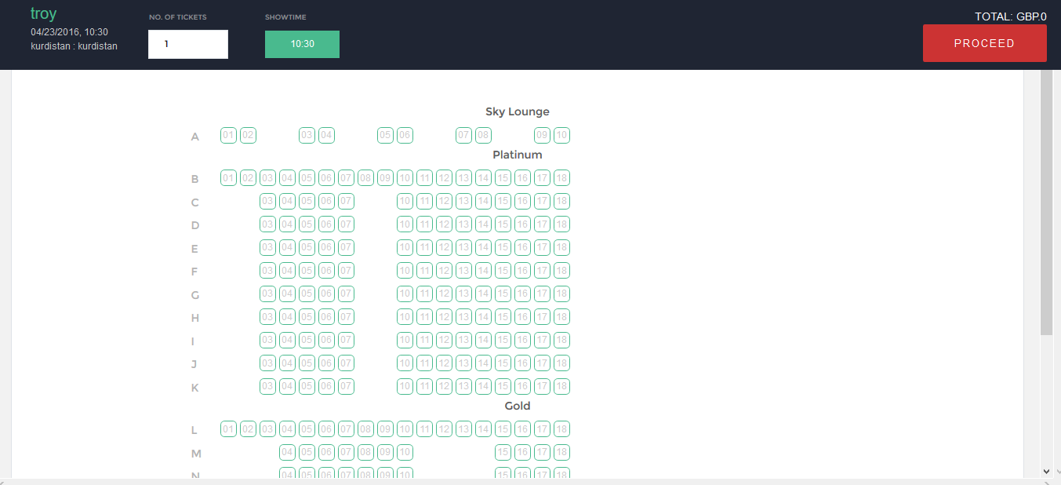

User need to login to process and purchase the ticket.

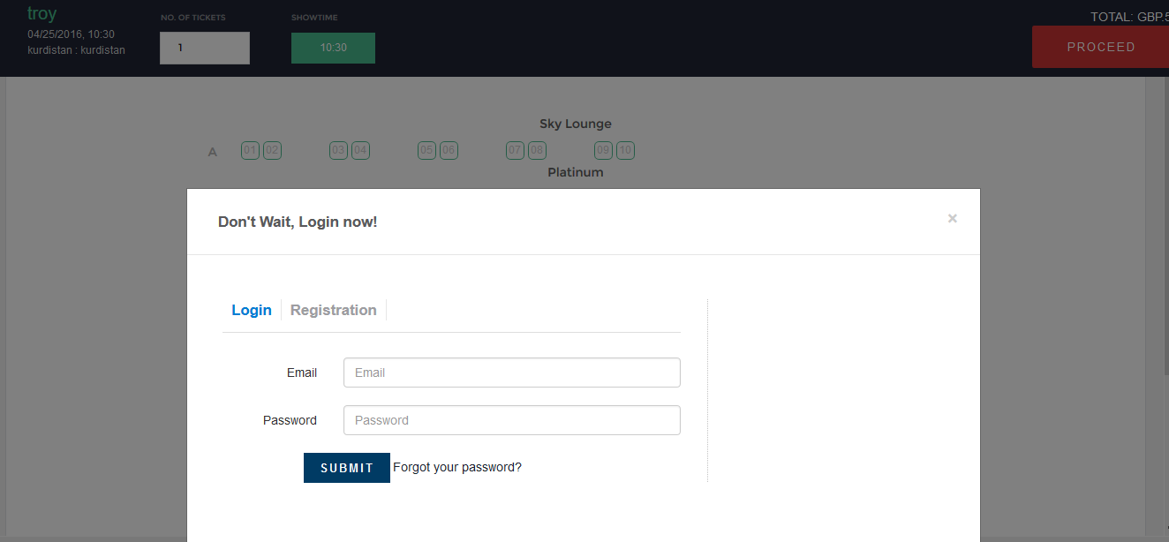

User would be able to register, once the registration completed, the user can access to the system and buy ticket

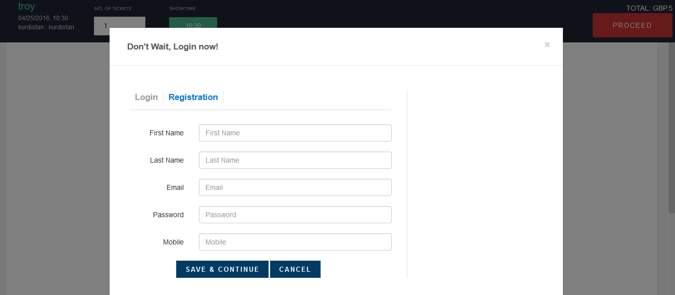

## References

1. www.developer.chrome.com/apps/app_frameworks
2. www.dsg.uwaterloo.ca/seminars/notes/2013-14/PaulLarson.pdf
3. www.db.cs.berkeley.edu/papers/fntdb07-architecture.pdf
4. www.w3schools.com/js/
5. www.w3schools.com/html/html_css.asp
6. www.owasp.org/index.php/CrossSite_Request_Forgery_(CSRF)_Prevention_Cheat_Sheet
7. www.asp.net/mvc
8. www.//go.microsoft.com/fwlink/?LinkId=301880
9. www.w3schools.com/bootstrap/
10. www.developer.paypal.com/docs/classic/express-checkout/integration-guide/ECGettingStarted
11. www.cs.umd.edu/users/ben/goldenrules.html